Project Handover Document

**Redback Operations**

Project Sun Cycle

*Trimester 3, 2022*

Table of Contents

1. Project Information 2

1.1. Company Acting Director 3

1.2. Project Team 3

2. Project Overview 3

3. User Manual 3

3.1. Microsoft Teams 3

3.2. Trello 4

3.3. Unity (Editor Version: 2020.3.37f1) 8

3.3.1. Installation and setup 8

3.3.2. Basics of Unity 13

3.3.3. Build Settings 16

3.3.4. Using VR Headset 17

3.4. Plastic SCM 19

3.4.1. Setup Plastic SCM 19

3.4.2. Using Plastic SCM 21

3.5. Blender / Maya / 3D Max 24

3.5.1. Installation and setup of 3DMAX 25

4. Completed Deliverables 27

5. Roadmap 27

6. Open Issues 28

7. Lessons Learned 28

8. Product Development Life Cycle 29

8.1. New Tasks 29

8.2. Definition of Done 30

8.3. Task Review 30

8.4. Testing 30

8.5. Branching Strategy 31

9. Product Architecture 31

9.1. Tech Stack 31

9.1.1. Software 31

9.1.2. Hardware (Not required) 31

10. Source Code 32

11. Login Credentials 32

12. Other Relevant Information 32

13. Appendices 32

13.1. Showcase Video 33

13.2. Documentation Deliverables 33

13.3. Unity Deliverables 34

13.4. 3D Asset Deliverables 39

# Project Information

## Company Acting Director

**Name:** **Akan** **Cosgun**

Title: Company Director

Email: akan.cosgun@deakin.edu.au

**Name:** **Adrian** **Grigo**

Title: Company Leader

Email: agrigo@deakin.edu.au

## Project Team

Company: Redback Operations

Team: Virtual Reality

Channel: VR modelling and World Building Hub

**Project:** **Sun Cycle**

Members - 3

|  |  |  |
| --- | --- | --- |
| Name | Senior/Junior/Position | Role |
| Germain Spriet | Senior – Team Lead | Game Engine/Programming |
| Yucheng Shi | Senior – Team Lead | Game Engine/Programming |
| Hao Pan | Senior – Regular Member | Design/Asset Creation |

# Project Overview

Project Sun Cycle is a Virtual Reality based game which is played in combination with an exercise bike. In this single player experience the player is able to explore and travel across the post-apocalyptic tribal world completing quest such as delivering goods between the different tribes on their hover skater-bike. The aim of this project is to create a fun and immersive experience that will encourage people to exercise more with the increased motivation of being able to play a video game simultaneously.

An overall goal of incorporating enjoyable yet challenging quests within the game will help test the endurance/strength of the players and keep them exercising on a regular basis. Another aspect of this is incorporating a beautiful in game environment to visually impress the player as they travel around the game world.

In conclusion as stated above this project aims to solve the problem of low motivation to exercise by gamifying an otherwise boring workout.

# User Manual

## Microsoft Teams

Once added to the Redback Operations Company use the “VR Modelling and World Building Hub” public channel for communication and file storage.

Communication

Communicate with your team using posts, personal messages and making sure to engage in scheduled meetings to have discussions about the project.

File Storage

Store any contributes, ideas and important files within the files section of the channel. Make sure to organize your content by categorizing it into its respective folder.

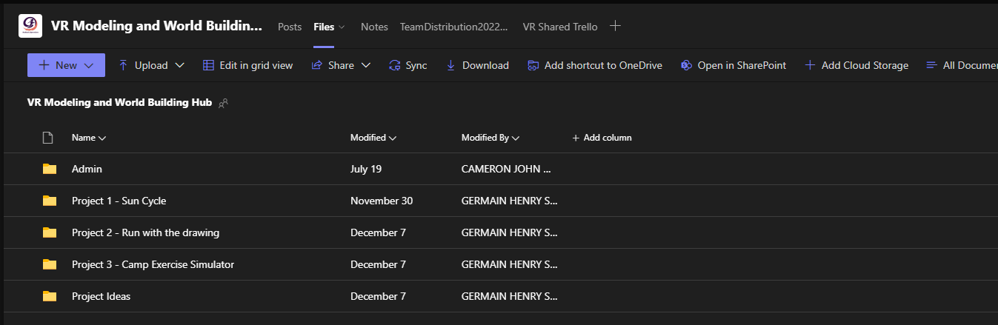

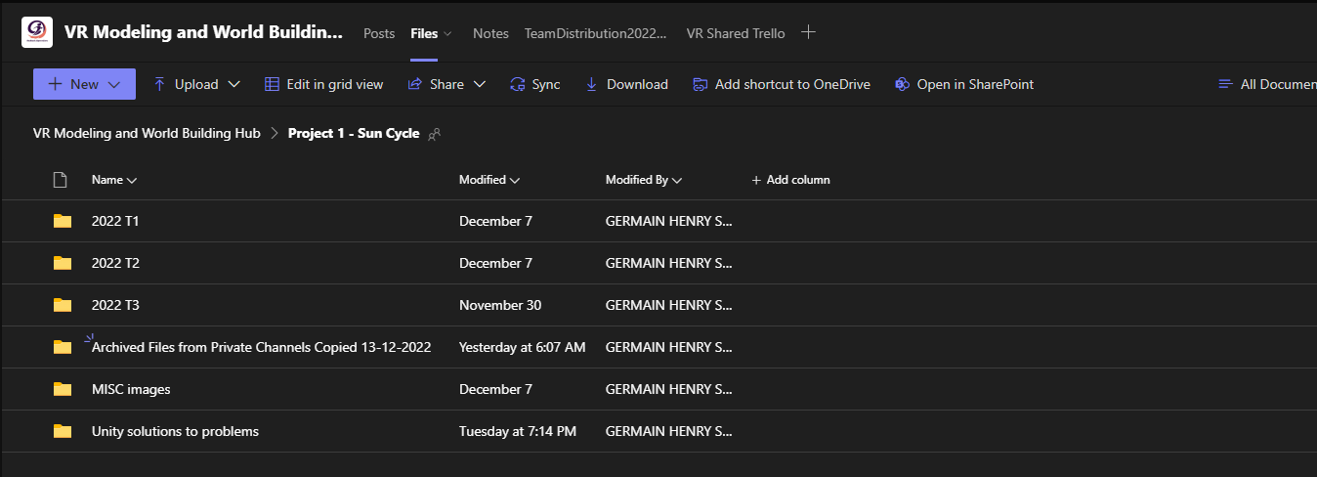

## Trello

We use Trello to organise the tasks that need to be completed, the status of said tasks and who is assigned to each of the tasks.

Overview

This image demonstrates how we categorize our cards (tasks) into their respective statuses such as “To Do”, “Doing”, “Done” and “Backlog” which contains tasks from the roadmap (past trimesters) that we could decide to work on. To move these cards to a different list you can just click and drag them.

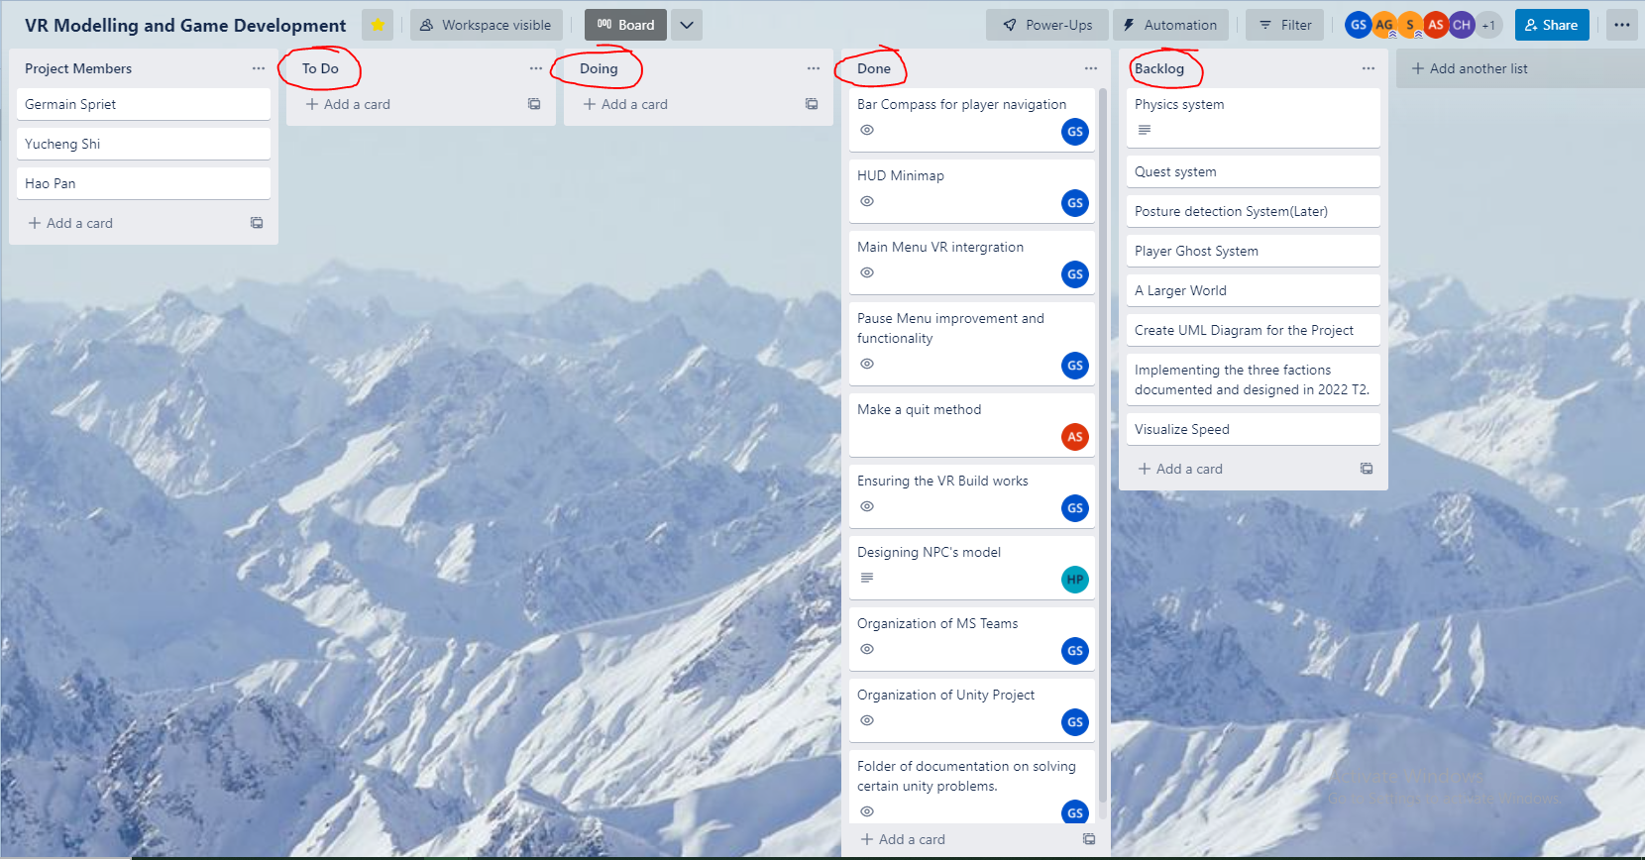

New Tasks

1. When you want to create a new task, you can click the “Add a card” button under each list.

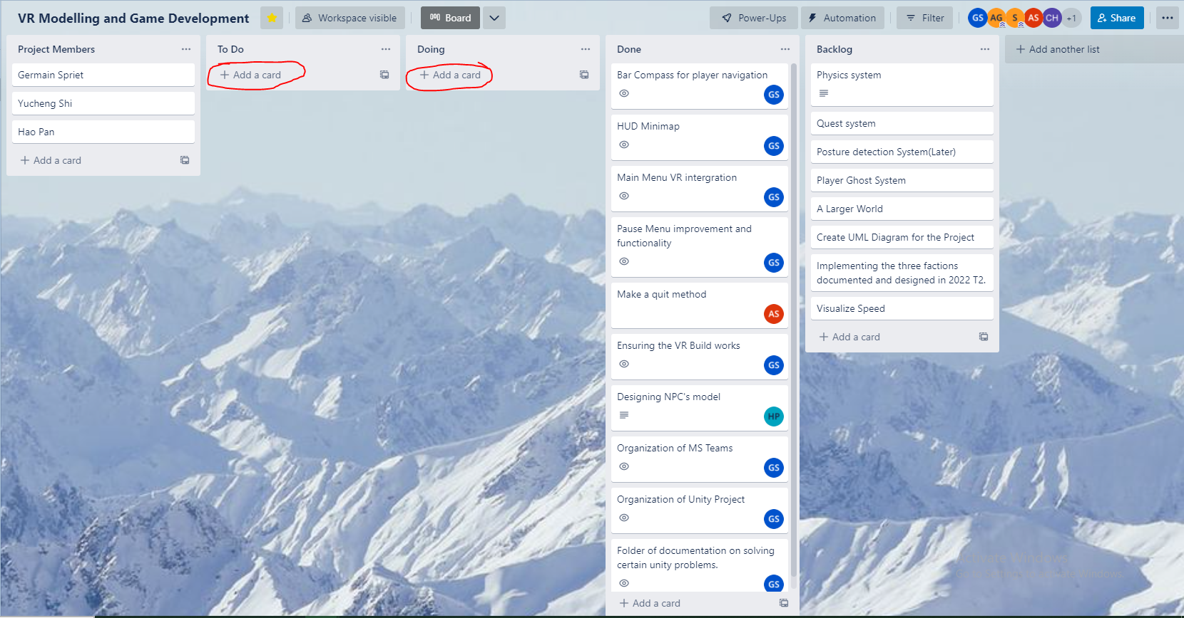

1. You can then add a task title to that card.

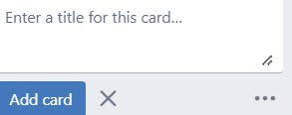

1. Once you have a new card you can select that card to go into the details and add a description to better define the workload of the task.

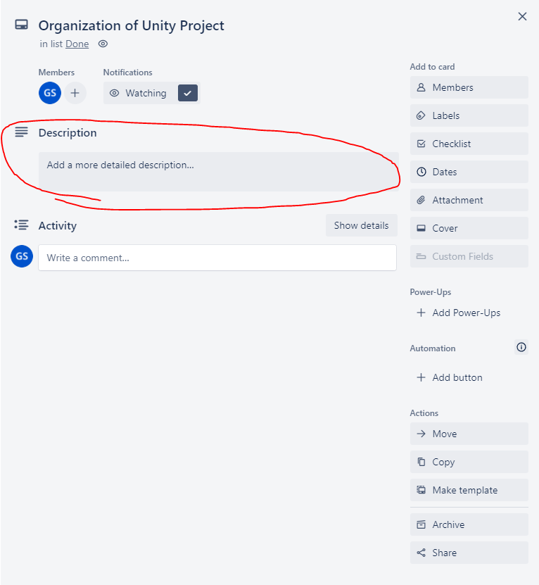

New Lists

1. If you want to add a new list to help categorize your cards, click “Add another list”.

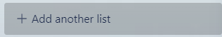

1. Once you have clicked that enter the name of list you want and then click “Add list”.

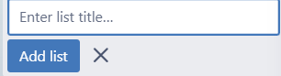

Assigning Members

When you have decided on a task you want to contribute to you can drag a user from the top left onto a card to assign that team member to the task.

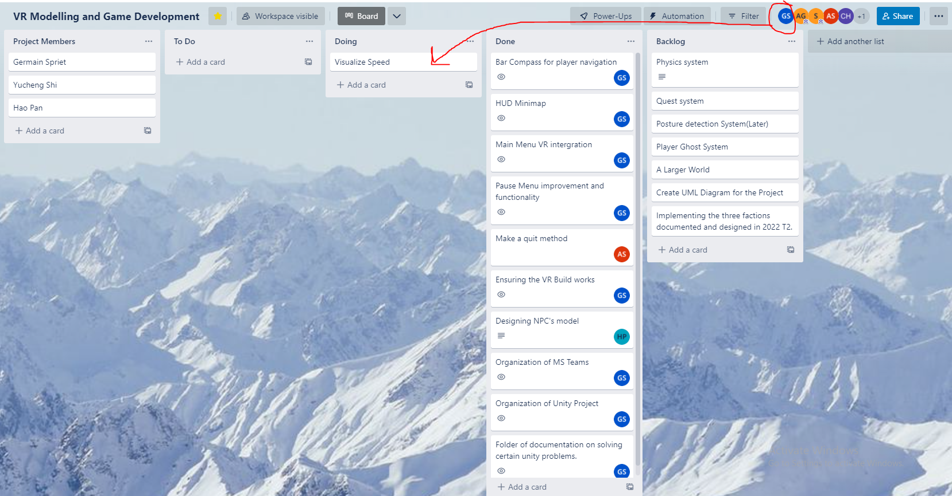

Trello activity history

1. To see the activity in Trello, click the three-dot icon in the top right.

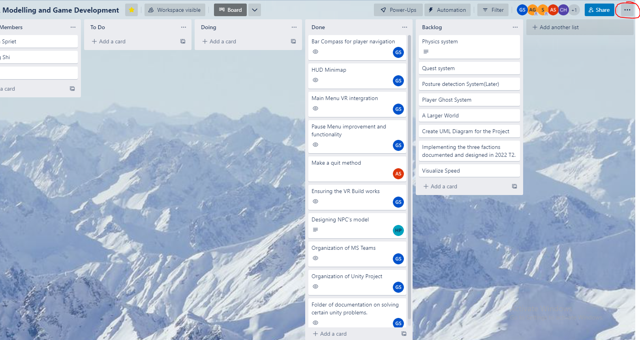

1. You can then see the history of your Trello board’s activity.

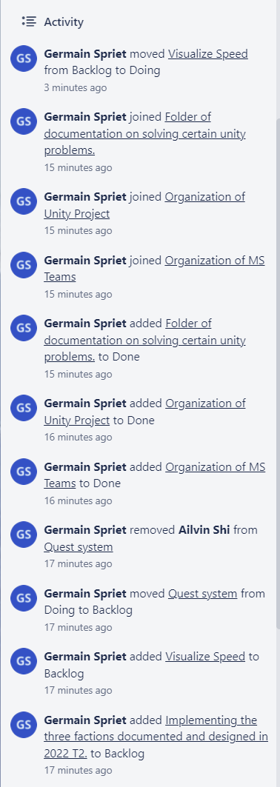

## Unity (Editor Version: 2020.3.37f1)

Unity is the game engine we use to develop our project. We are using Editor version 2020.3.37f1.

### Installation and setup

1. The First step is to create a Unity account. Go to the Unity website and “Create a Unity ID” (make an account).
2. The second step to using the Unity software is downloading it. Go to this link: <https://unity.com/download> and select and download the version that matches your circumstances (Operating System). Once downloaded execute the setup for the Unity Hub.
3. Launch Unity Hub and after you have logged in you will get something like this.

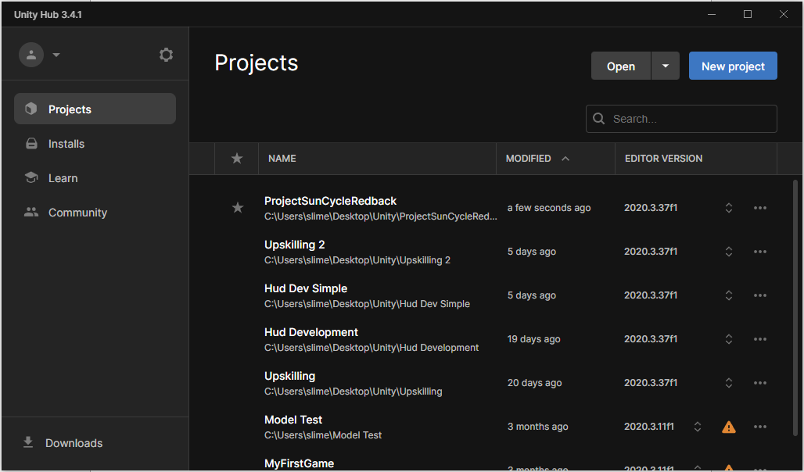

1. Now we will need to install the Editor Version that we are using for the Sun Cycle project. Go to the “Installs” tab on the left and then click the “Install Editor” button in the top right.

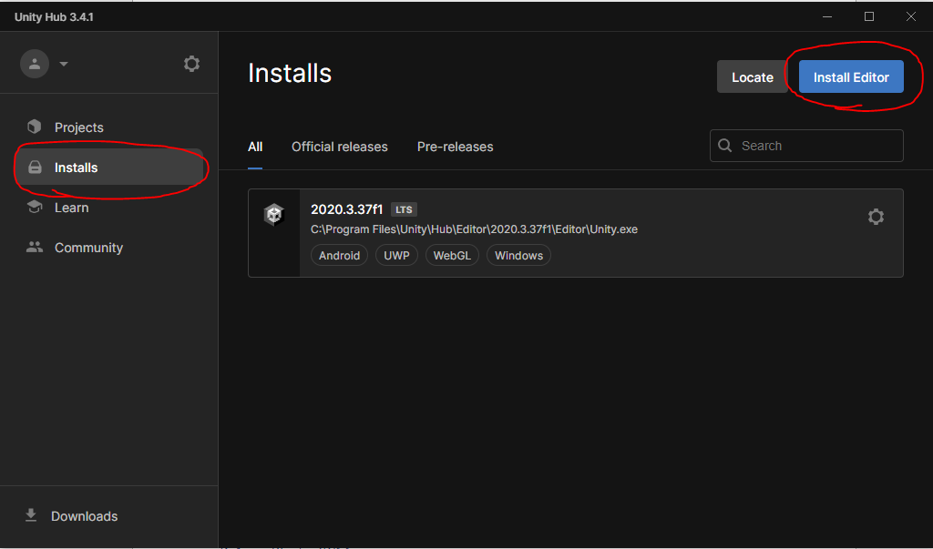

1. Then click on the "Archive” tab and click the download archive link (<https://unity.com/releases/editor/archive>).

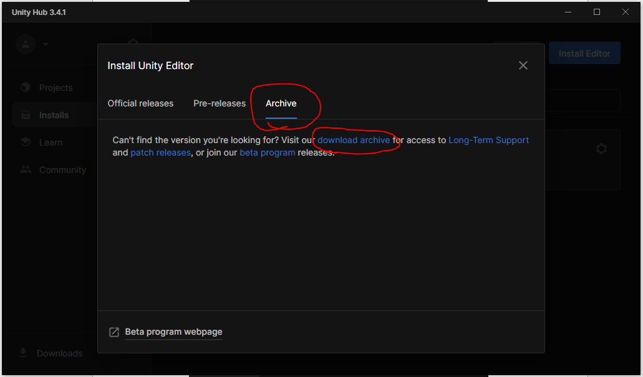

1. Then scroll down and select the “Unity 2020.X” tab. Then scroll down to the Unity Editor Version 2020.3.37 and click the “Unity Hub” button.

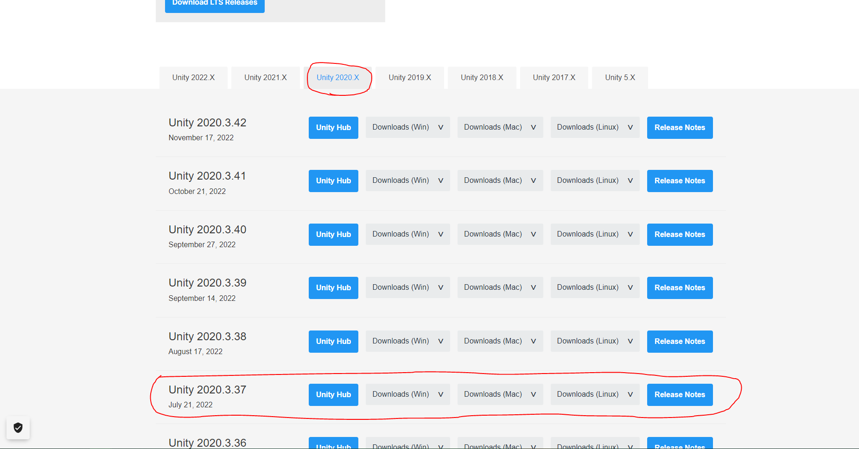

1. This will take you to the Unity Hub again where we will get to choose the Modules we want to add to the Editor. In this case we will want to add the Android Build Support for the VR headset.

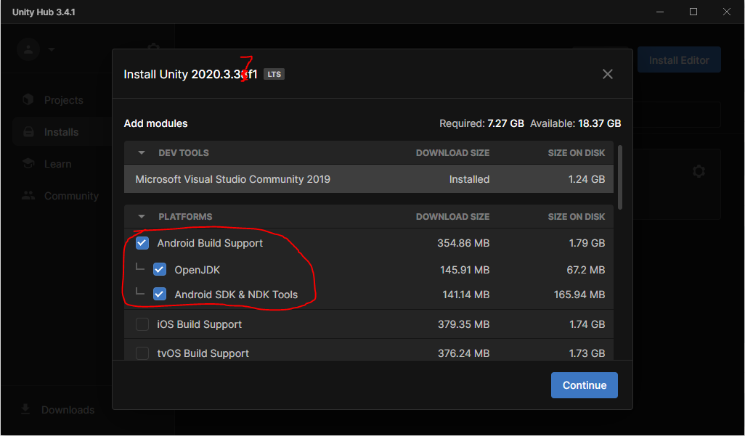

1. You can also choose to add other modules if you wish to test or build the project for other platforms. For example, I might select these modules as I use Windows OS:

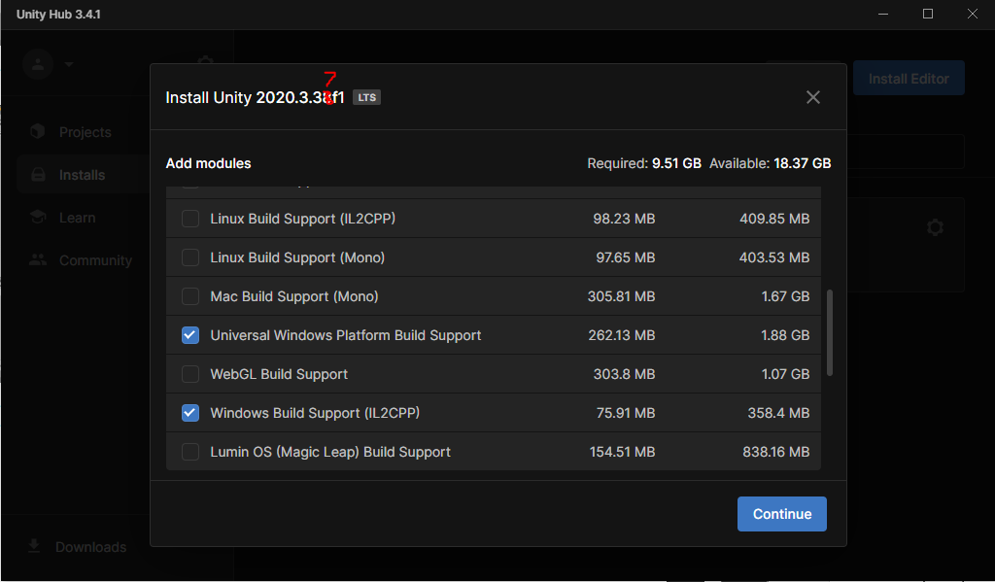

1. Then click "Continue” and accept the terms and conditions and click “Install”

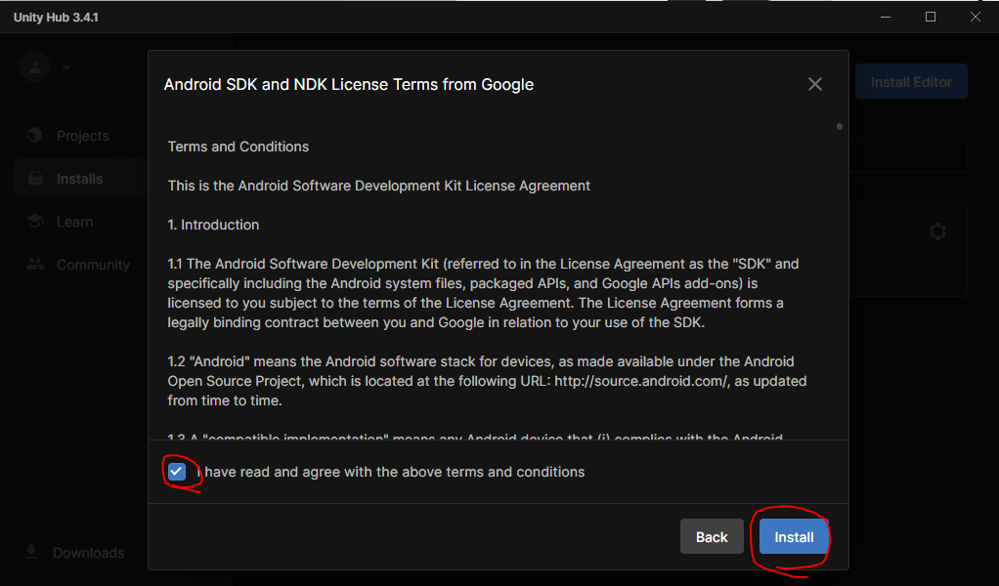

1. Once it is done installing should show up in the “Installs” tab.

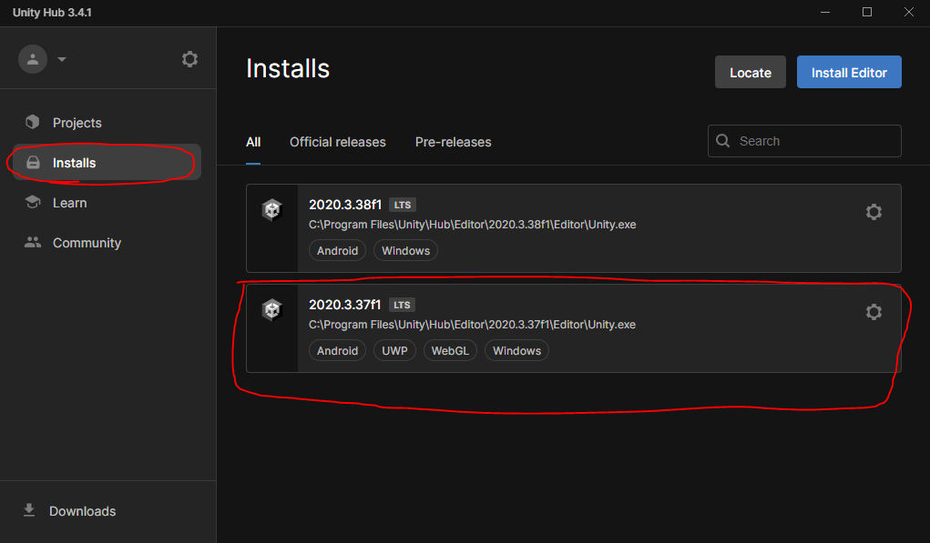

1. Then once you and your team leader have gone through section **3.4.1 Setup Plastic SCM** you will need to navigate to the “Projects” tab -> “Open” dropdown -> “Open remote project”.

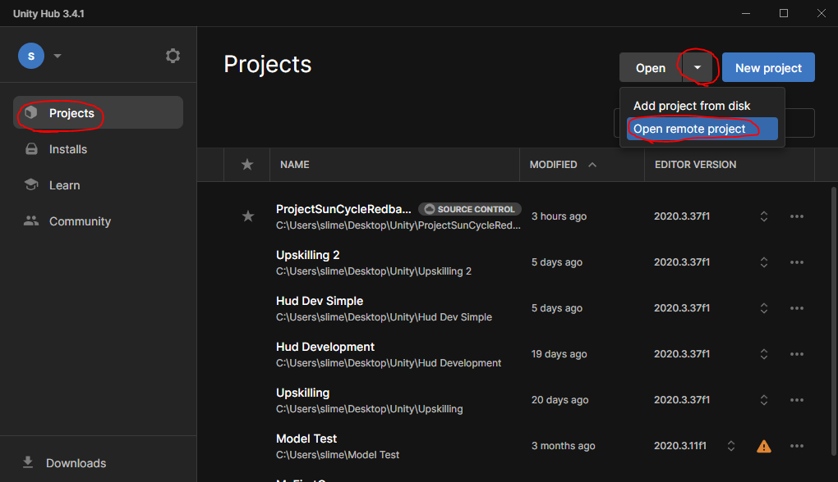

1. Then select “ProjectSunCycleRedback” and open it. (I already did it on my system, that’s why it says “Added”)
2. 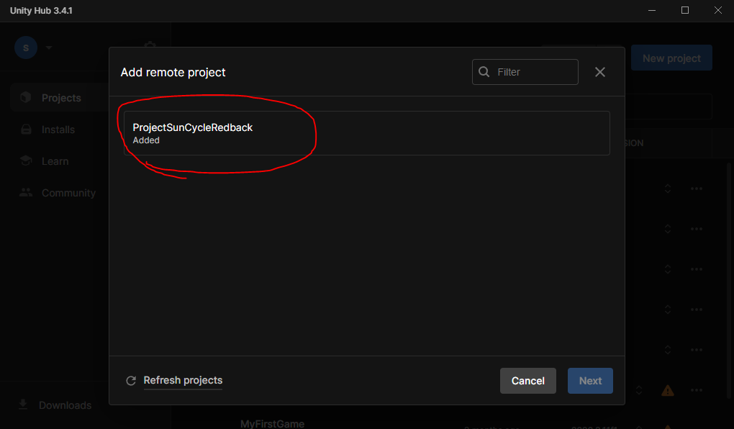
3. Then you should be able to see and access the project from the “Projects” tab in your Unity Hub. You can also favourite it too if you want with the star.

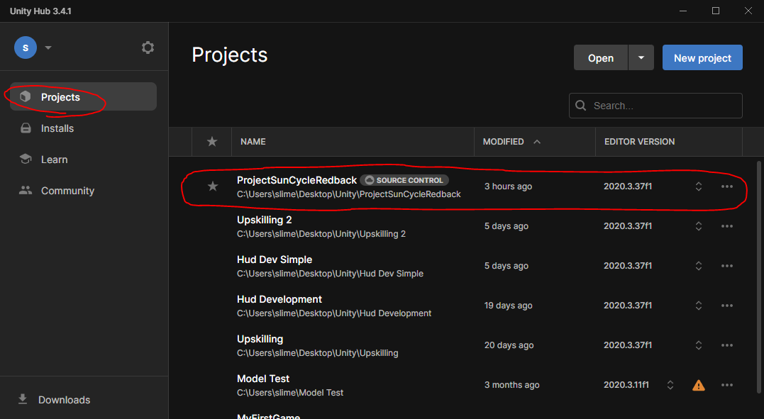

### Basics of Unity

Below explains the functionality of some of the most important windows/panels in Unity but there are many more you can use for specific things. It’s a good idea to Upskill in Unity before usage.

Hierarchy

This contains all of the game object that are currently within your scene, in this case “MainScene” contains “HumanoidNPC” which you can see in the middle.

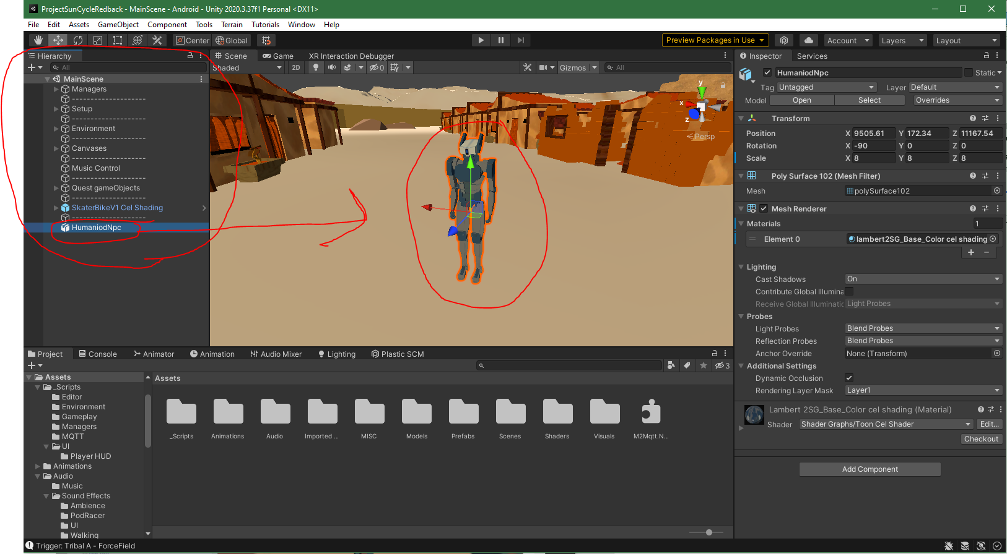

Scene

The scene is kind of like a level in a game, you add things to the scene that you want in that level. Through this screen you can add and manipulate the game objects in the level and design the world just the way you want it for the player to experience it.

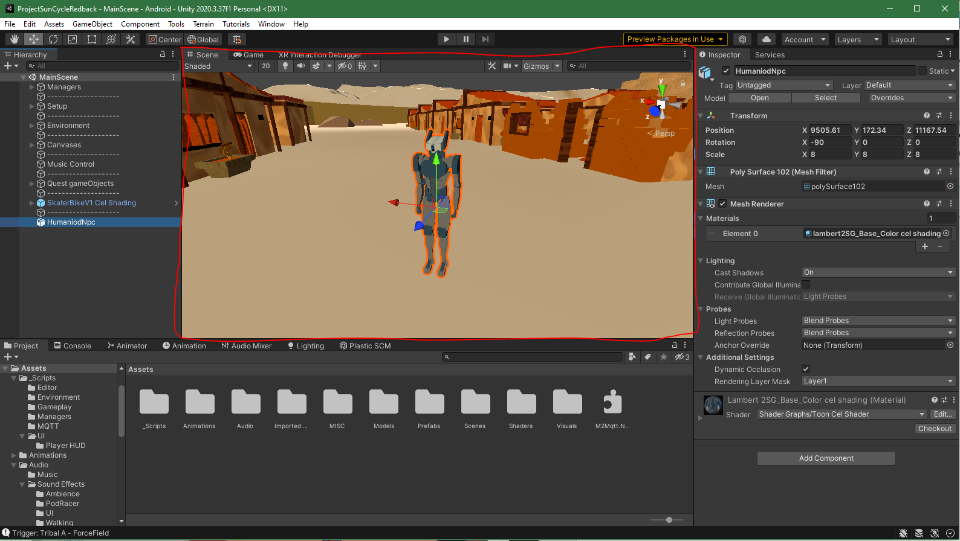

Inspector

Once you have clicked on something in either your Hierarchy or your Scene to select it the Inspector will pop up with the details of the selected object. It will show you all the different components of that game object, in this case the robot has a transform (position, rotation and scale in world space) and mesh renderer (renders the 3D mesh and material). Though this panel you can add or manipulate components.

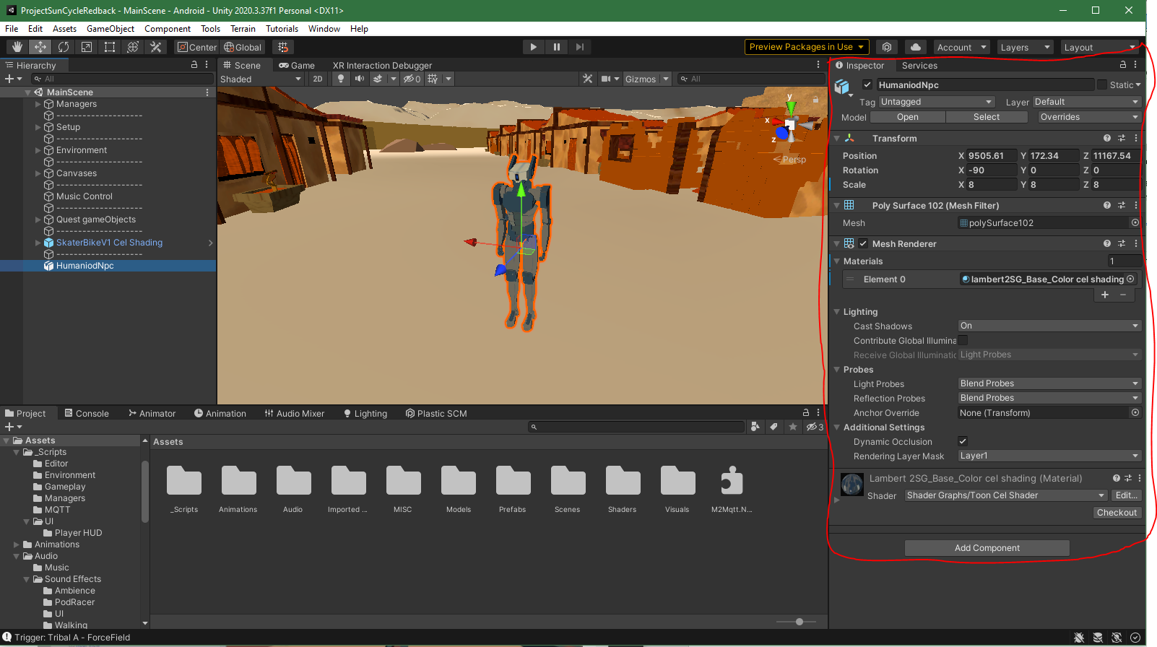

Project Directory

The project directory stores all of the assets that you are using in your project, things such as Audio, 3D models, textures, scripts, shaders, etc. You can use these assets to create game objects in any way you want. You should try to keep these files organized with simple understandable names.

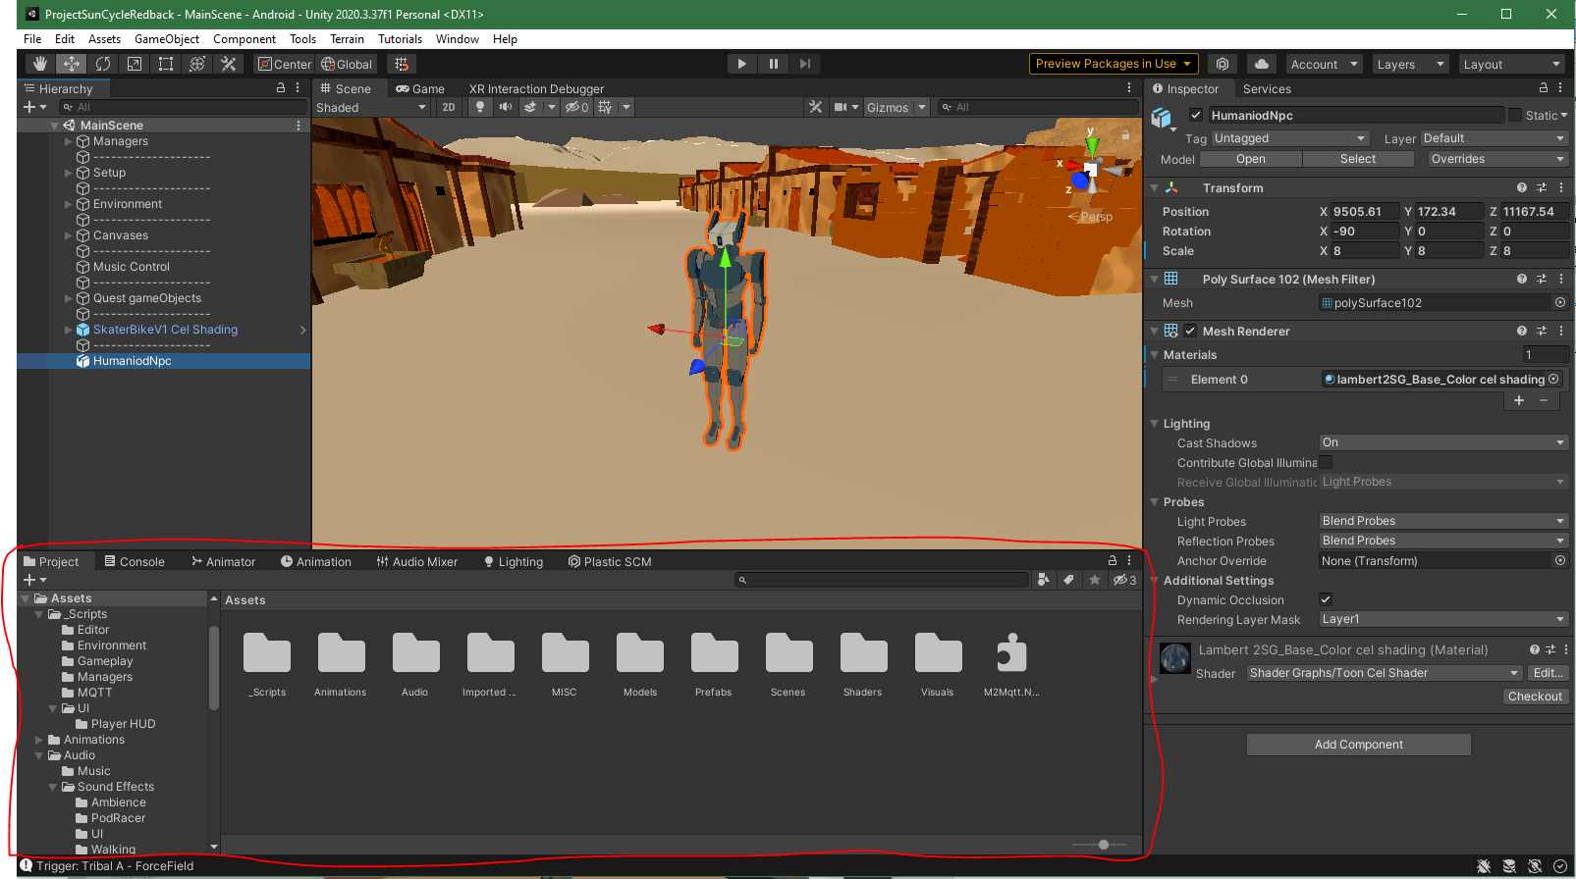

Console

You can use the console panel while testing your game to debug your game and ensure it is free of errors. The three clickable boxes in the top right of the panel allow you to turn on debug messages, warning messages and error messages. You use these messages to diagnose and fix problems with the project.

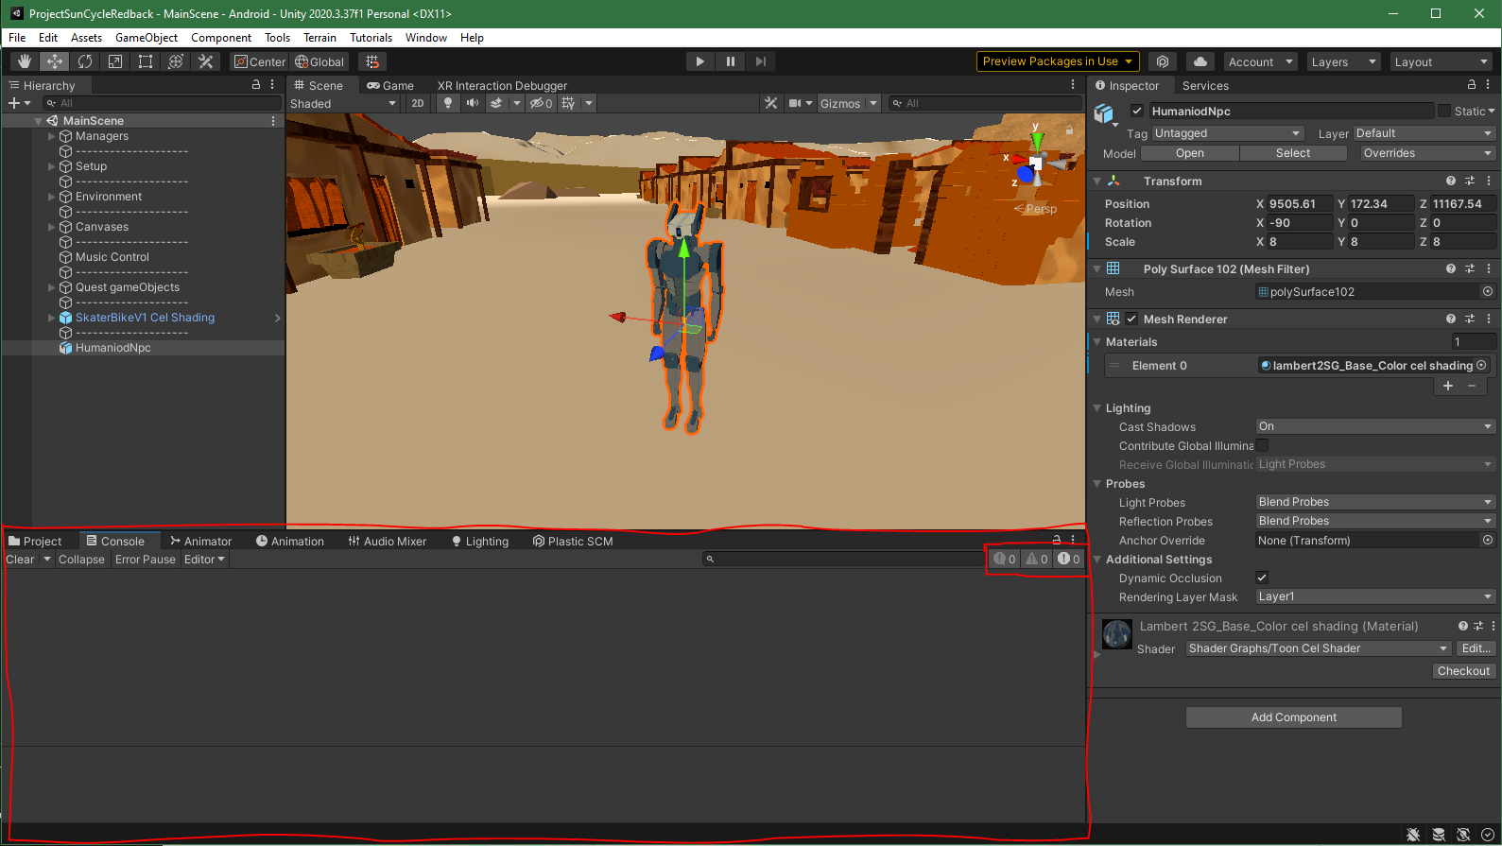

### Build Settings

Building the project is basically the process of creating the stand-alone version of the game that can be run on a specific platform as an executable. Because we want this game to run on a VR headset, we need change the platform to Android.

1. Go to “File” -> “Project Settings…”

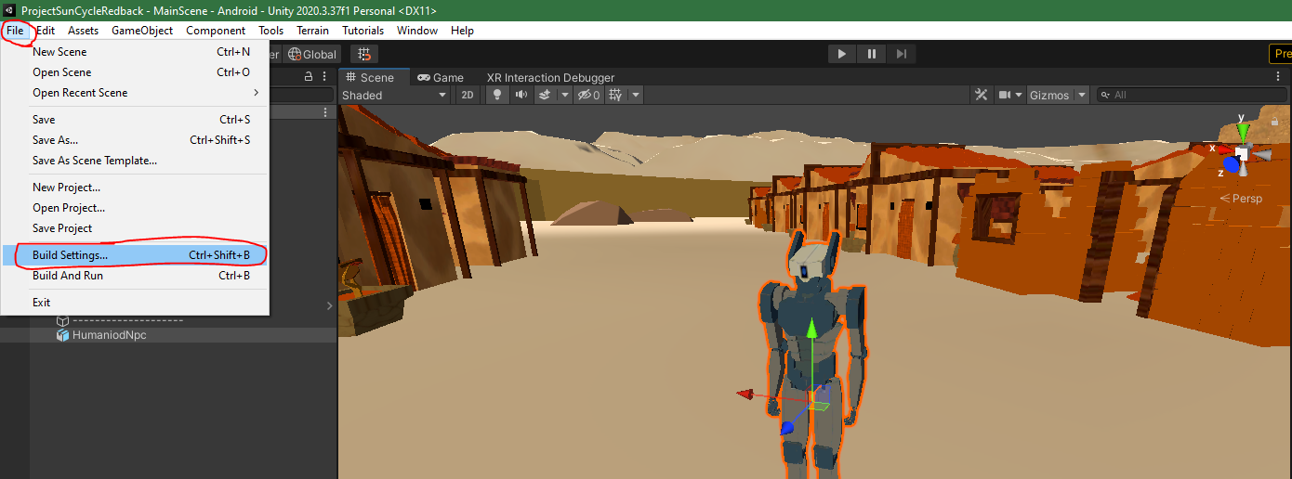

1. Once you are in the project setting click on the “Android” tab and click “Switch Platform”

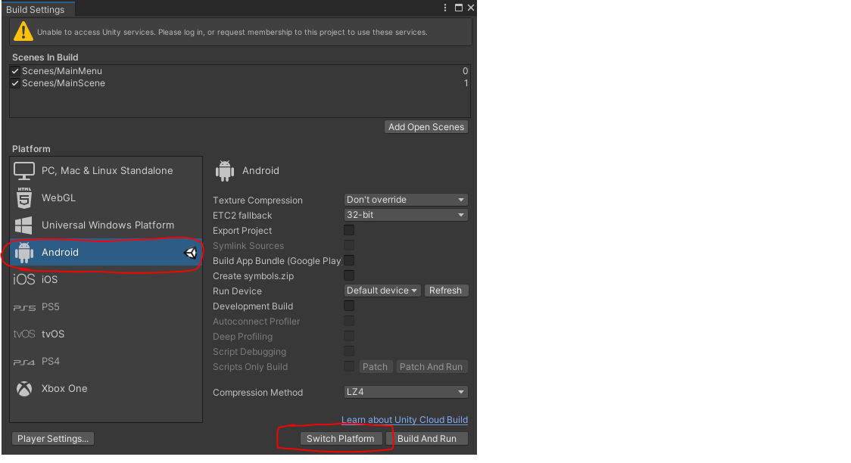

1. After this process is finished you will be able to make a build of the project by clicking the “Build” button, this will be stored as an executable file wherever you choose the location to be.

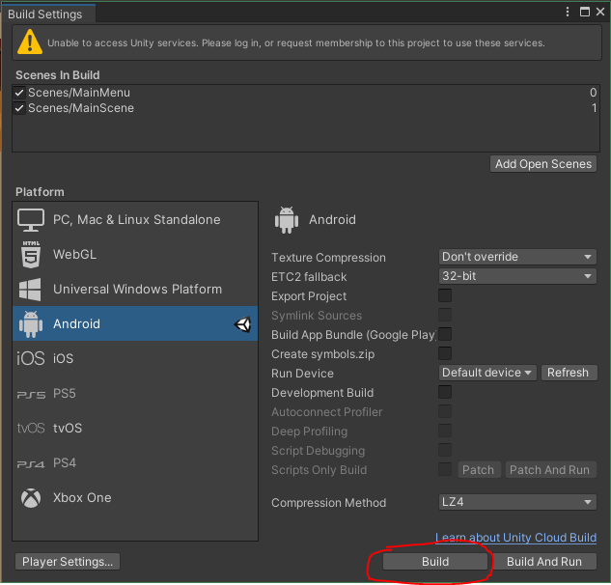

### Using VR Headset

**Note**: this section contains biased information based around the Oculus/Meta Quest 2 headset.

1. Have Oculus application open.
2. Have Unity project open.
3. Install & Setup oculus app on your phone.
4. Watch this short video to turn on developer mode on your headset: <https://www.youtube.com/watch?v=75dHXROt4mE&ab_channel=HowToGeek>
5. Connect VR headset to computer using cable (or use air link, not recommended).
6. Accept popups on the headset.
7. Launch Quest link on headset.
8. In Unity go to “File” -> “Build Settings...”



1. Then go to the “Run Device” section and hit “Refresh”, once that is done click the “Default device” dropdown and select “Oculus Quest 2”.

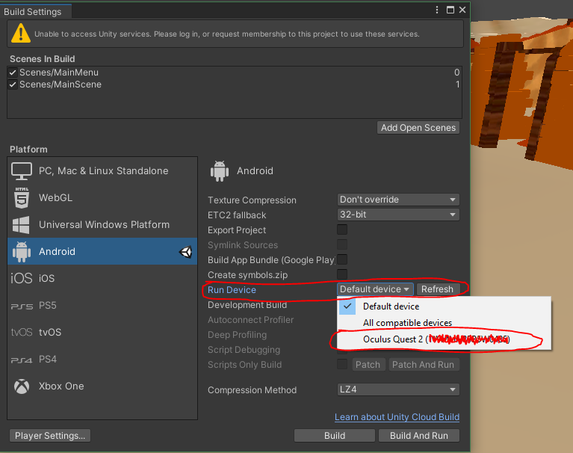

1. Click play button in Unity to test the game in the editor on your headset.
2. If you want to build a stand-alone version of the game on your headset, just click the “Build” button in the Project Settings and after it is done building you can unplug your headset.
3. To find the stand alone build go to your apps on your headset and click the dropdown menu in the top right and then sort by “Unknown Sources”.

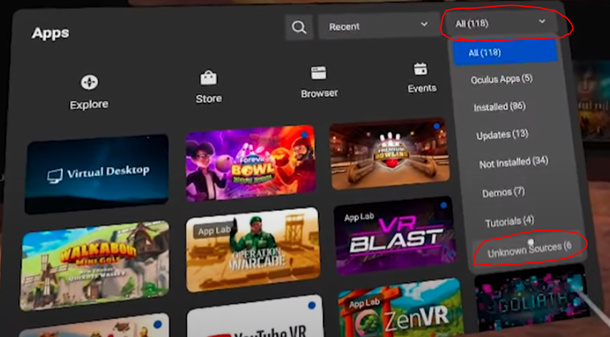

## Plastic SCM

Plastic SCM for Unity is the source control repository we use for this project as we have had problems using GIT in the past.

### Setup Plastic SCM

1. To begin using Plastic SCM you will first need to be added to the company account. If you are the **not** the team leader skip to step 6.
2. As the Team Leader you will need to gather all the team members Unity emails to begin administering the Unity users to the Plastic SCM Project.
3. Then you will need to go to the Plastic SCM website (<https://www.plasticscm.com/account/login>) and login using the Redback Companies credentials (**Refer to section 11 of this document**).
4. Once logged in and on your “Dashboard” go to “Cloud” -> “Configure” -> “Users and Groups”

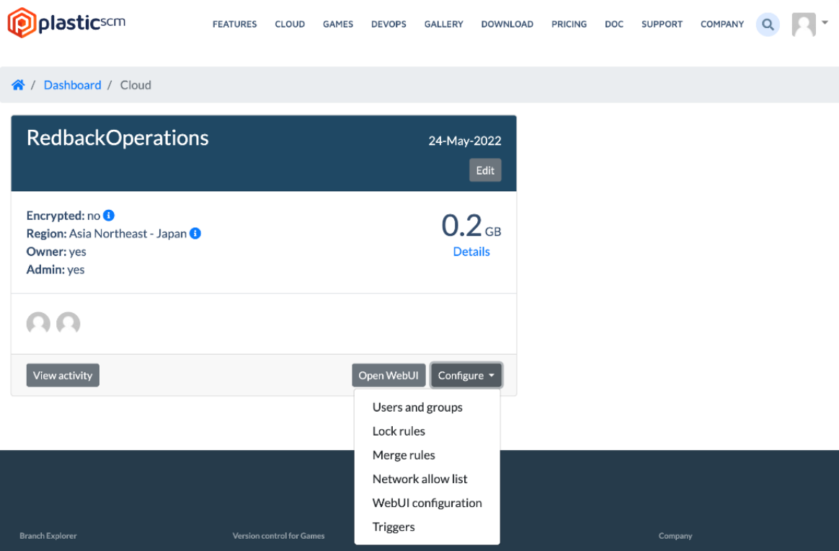

1. Then click the “Add new user” button after which you can enter the email associated with Unity accounts of the users who need access to the project.

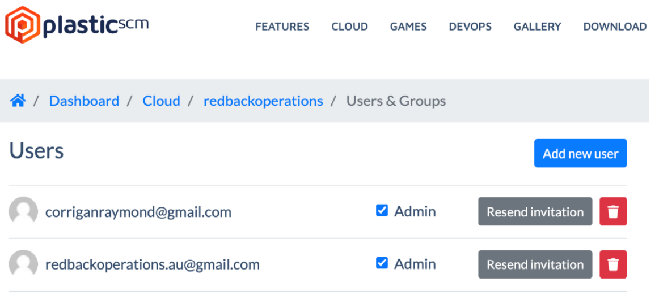

1. Go to the Plastic SCM download page (<https://www.plasticscm.com/download>) and download the “Cloud Edition”.

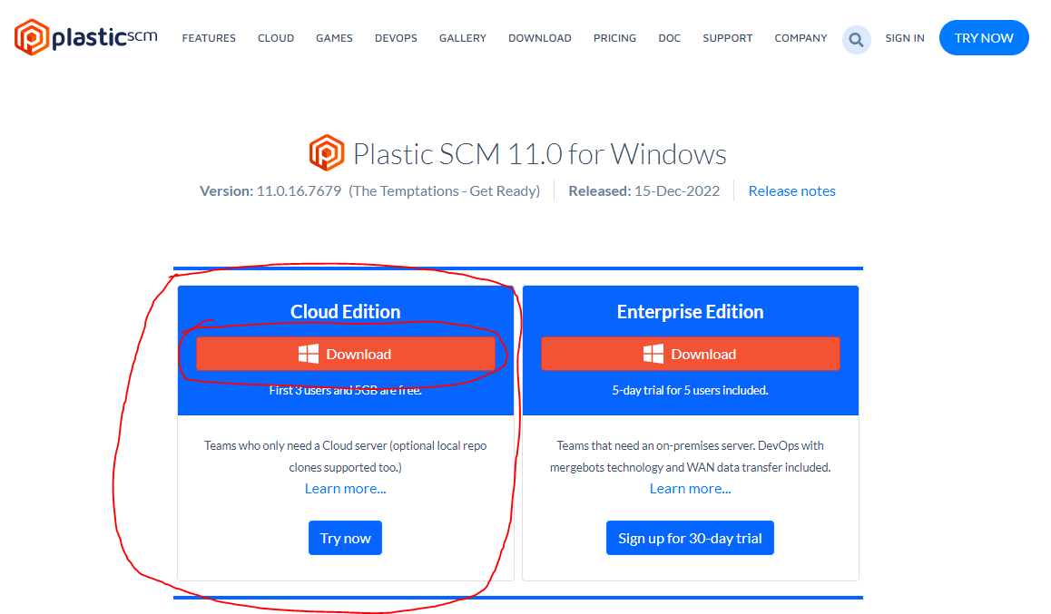

1. After you have executed the setup file you downloaded launch Plastic SCM and sign in using your Unity ID you should see something similar to this:

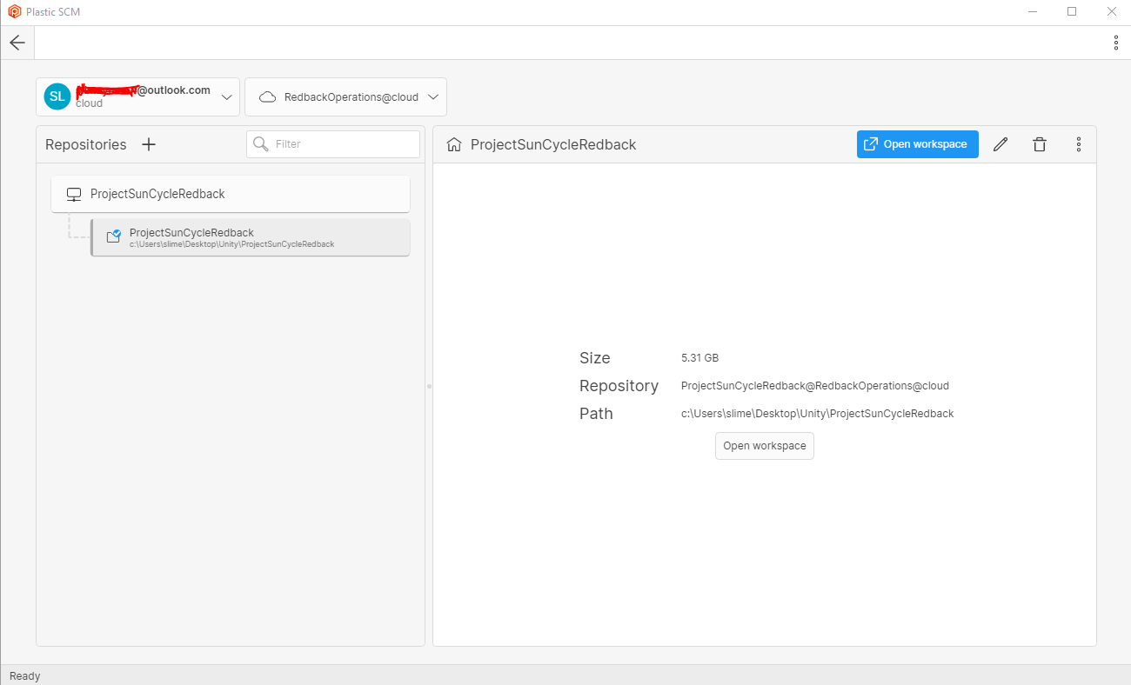

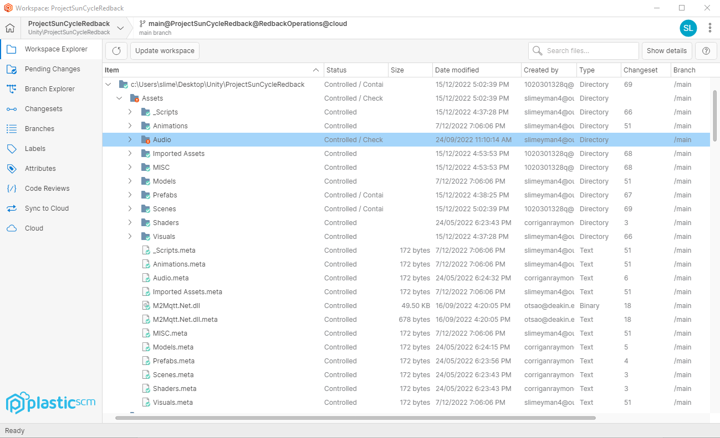

### Using Plastic SCM

Merging branches

1. Click the Plastic SCM button in the top right of Unity to bring up the Plastic SCM panel.

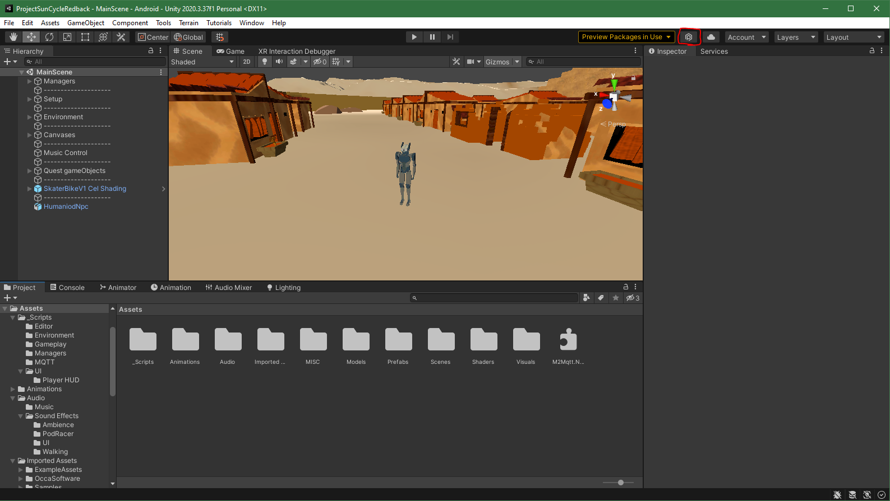

1. In the “Plastic SCM” panel click “Incoming Changes” tab and then click the “Update workplace” button to pull the latest changes to the project.

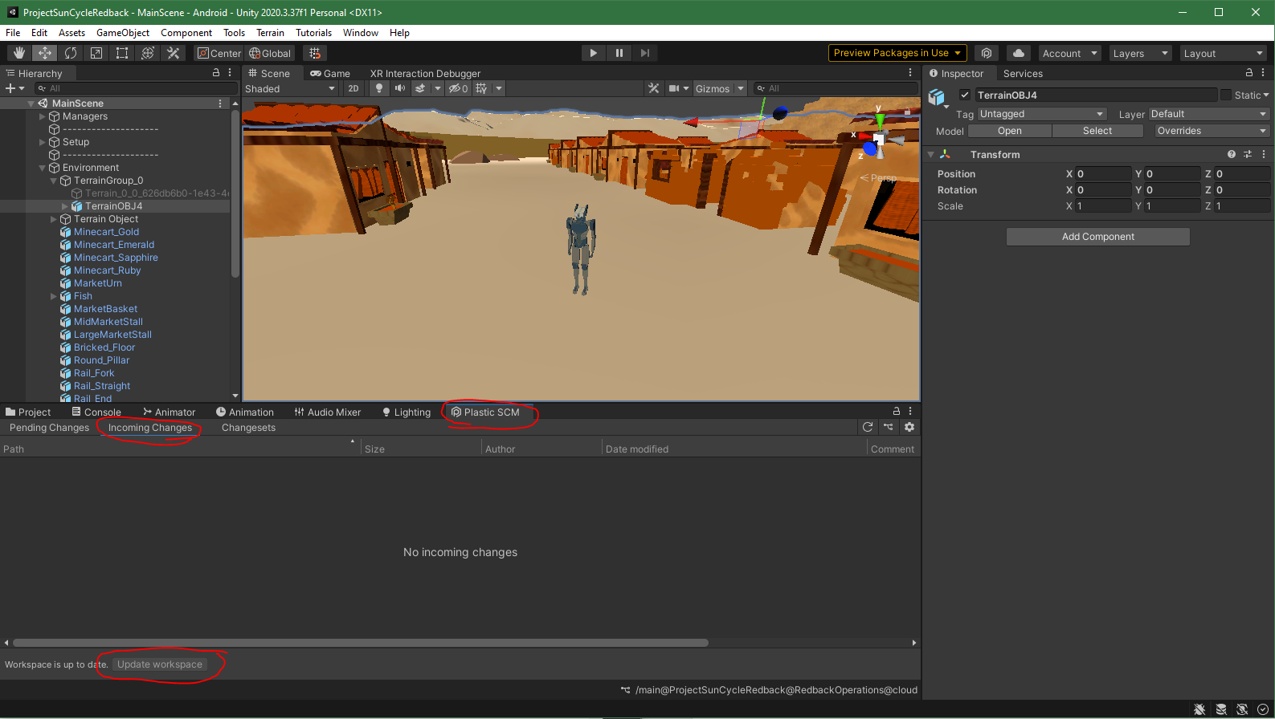

1. Click the branch symbol in the top right of the Plastic SCM panel and select “Branch Explorer”.

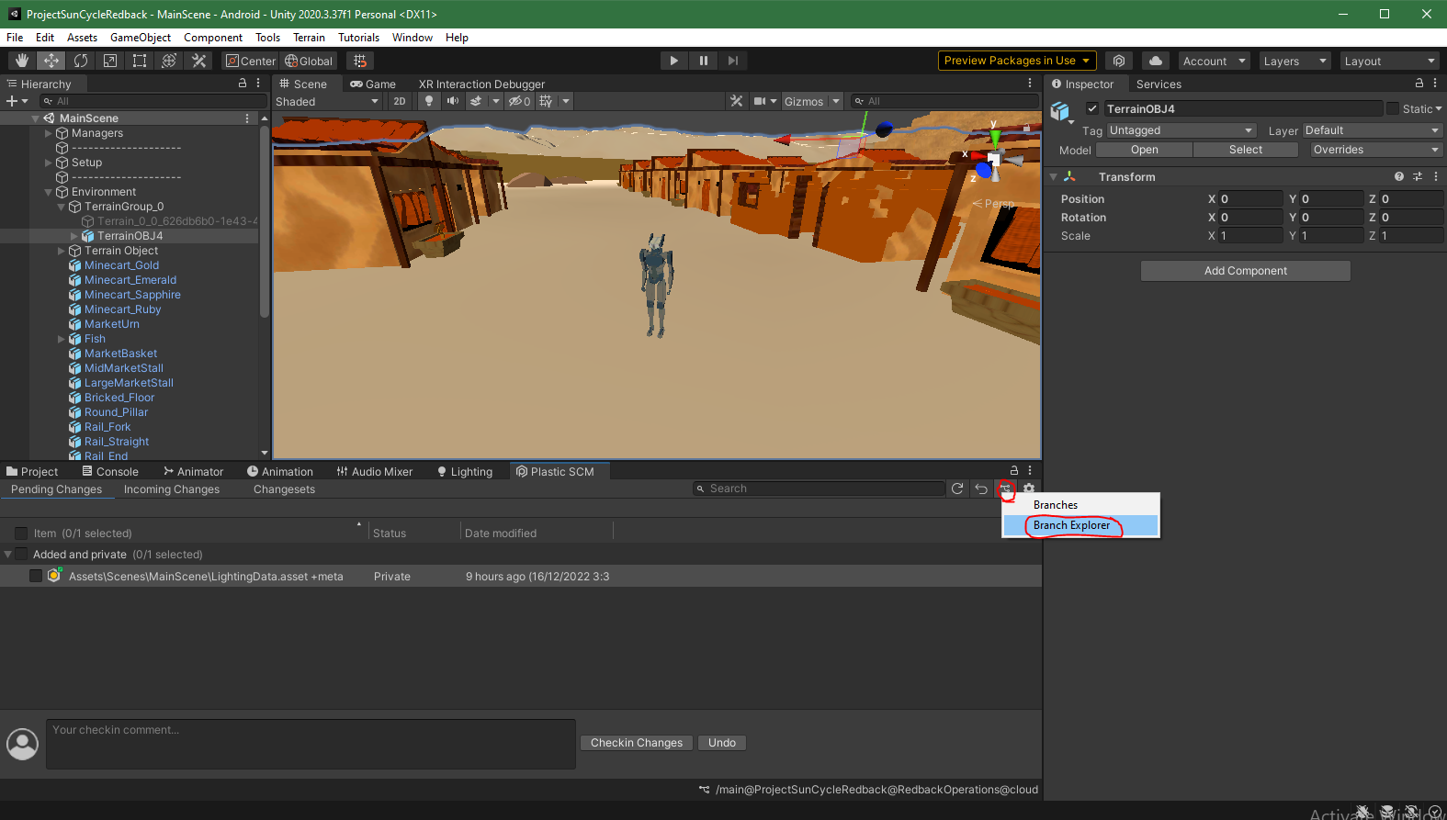

1. In the Plastic SCM application click the Branch Explorer tab on the left.

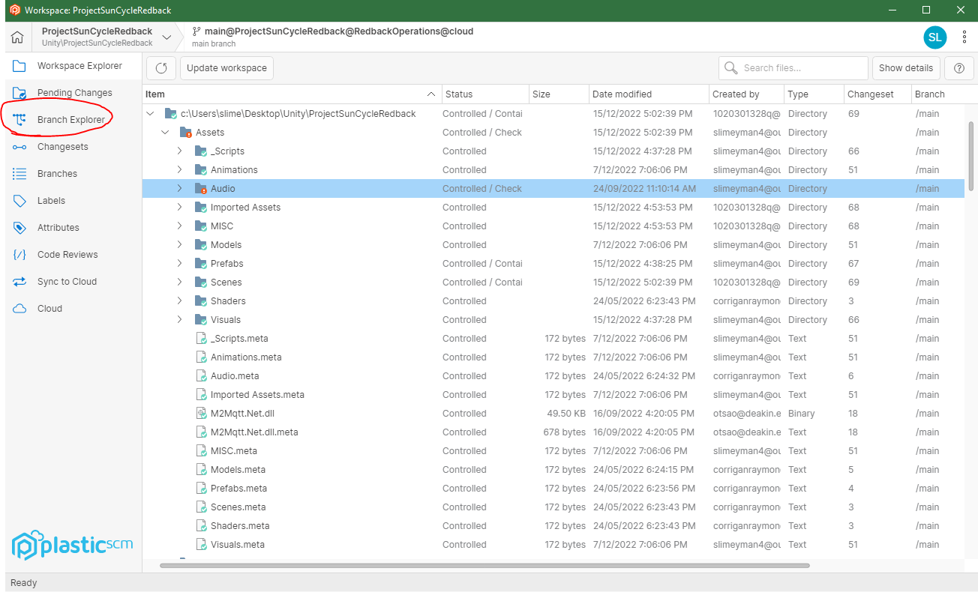

1. Right click the green house button (Main branch) and click “Create branch from this changeset...”.

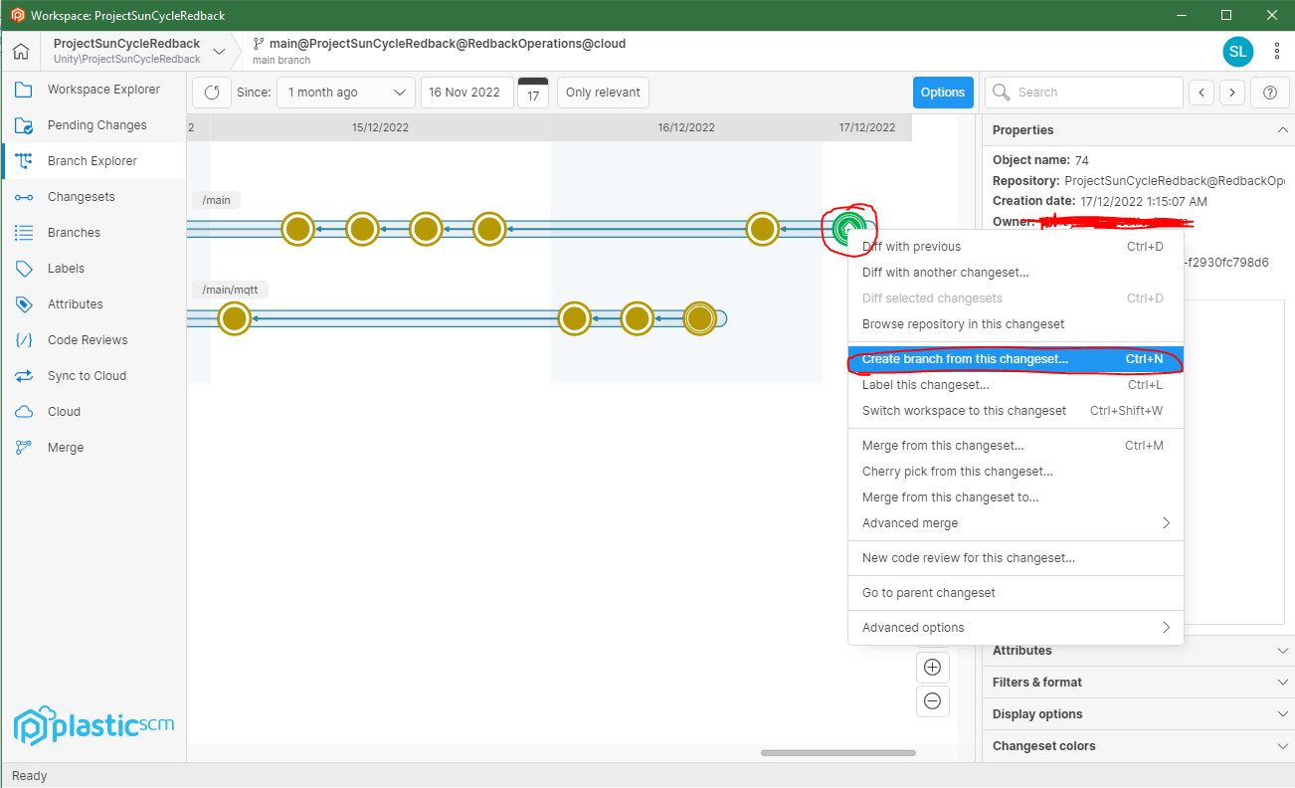

1. Add a branch name for the task you will be working on in this branch and add a comment about the branch. Then click create in the bottom right.

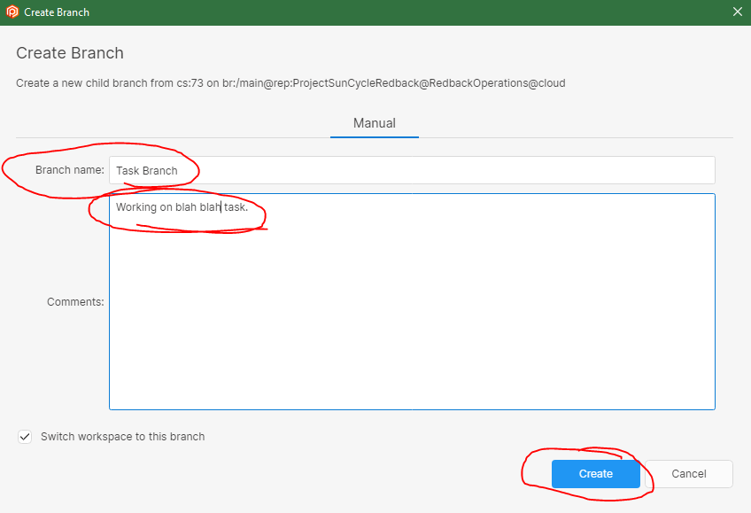

1. This will automatically switch your Unity workspace to the new branch. You can then make your contributions to the branch and check in your changes by going to the “Pending Changes” tab then clicking the checkbox to say you want to check in all items and then finally add checkin comments about what you changed before clicking “Checkin Changes”.

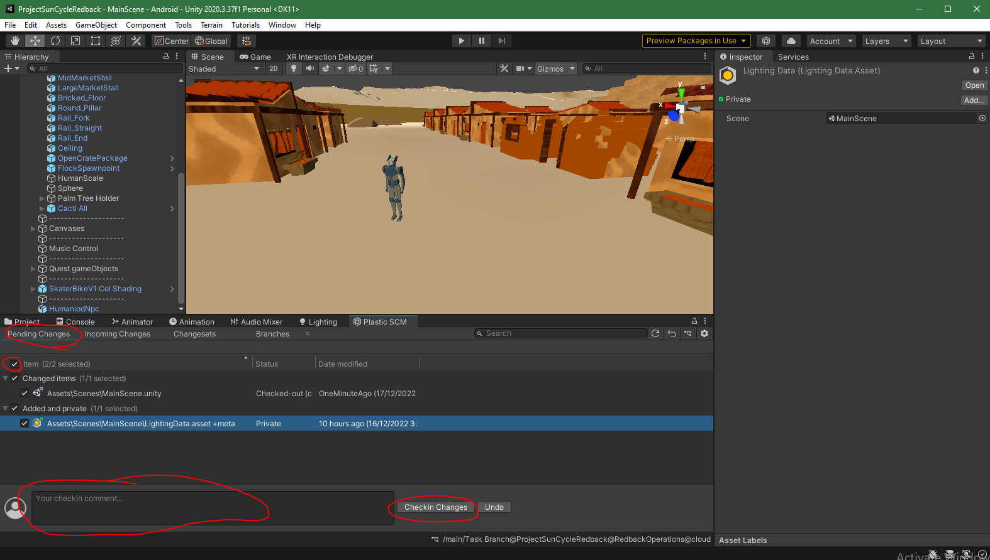

1. Then when you have completed your task get your team leader to review it and them merge the branch you were working on into the main branch.
2. Watch this video to learn how push/pull project changes in Plastic SCM: [How to: Group Projects with Unity Plastic SCM - YouTube](https://www.youtube.com/watch?v=AKU7Y-xkmTw)

Resolving Conflicts

Once the leader merged the new changes, if there is any error message come out after clicking update, just click Resolve conflict. In most situation, this operation can solve almost errors. Check the unity path has added into Plastic SCM as well.

## Blender / Maya / 3D Max

**Note**: this section contains biased information based around the 3D Max software. It’s your choice however for which 3D software you decide to use.

This section will contain basic information on how to use a 3D software application to create and export an asset.

### Installation and setup of 3DMAX

1. Create an Autodesk account if you do not have any, go to 3DMAX website and create a new account.
2. You can get a Free trial if you are a university student and did not use before, then choose the operating version and download Autodesk.

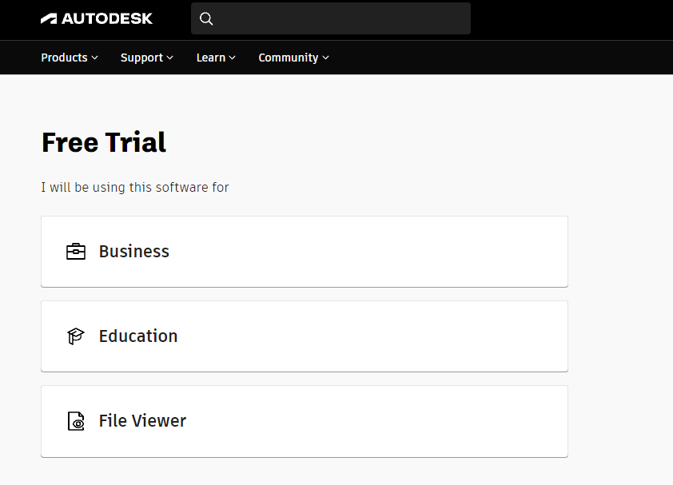

1. Open the Autodesk application, download the 3DMAX tool.

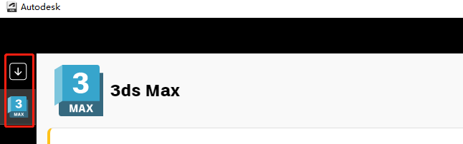

1. Open the 3D MAX software and use the tools provided to create your model.
2. You can then modify the model through the edit bar on the right while observing the model, but please note that model modification will affect the application of textures

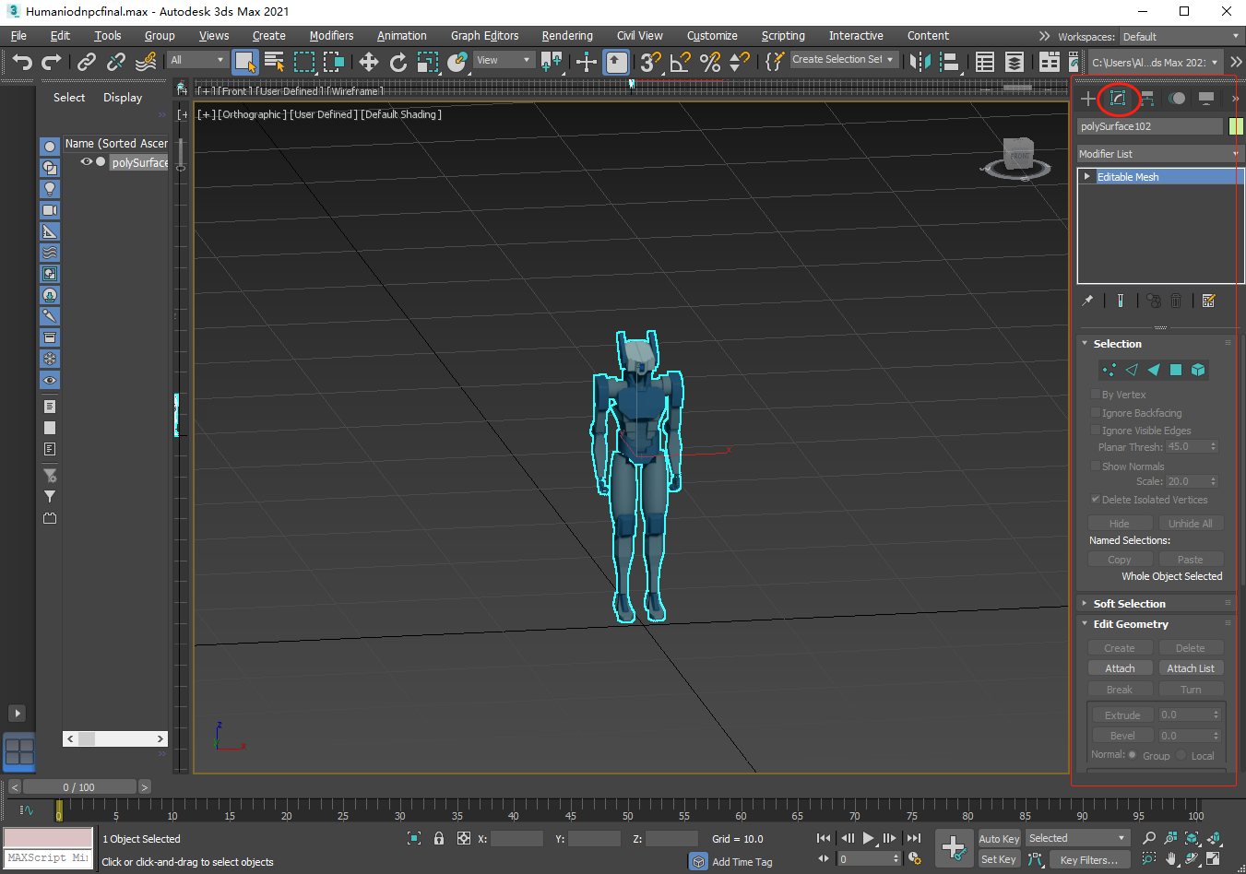

1. Click the shortcut key “M” to open the material editor, view the texture and apply the model by dragging the shader.

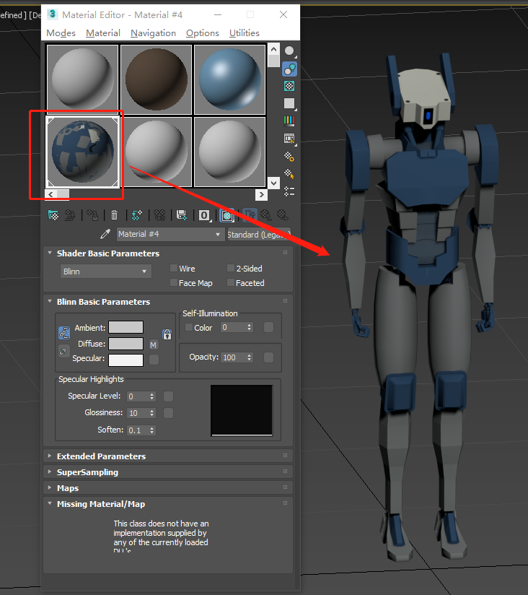

1. Export the model and convert it to any format you want.

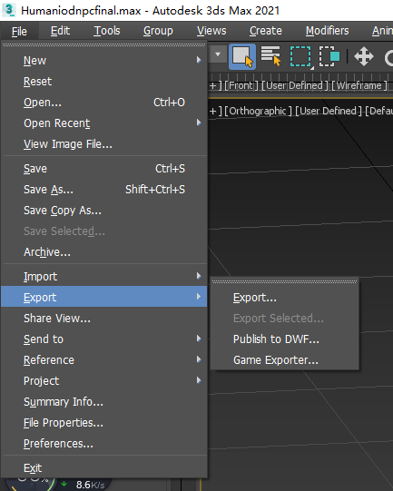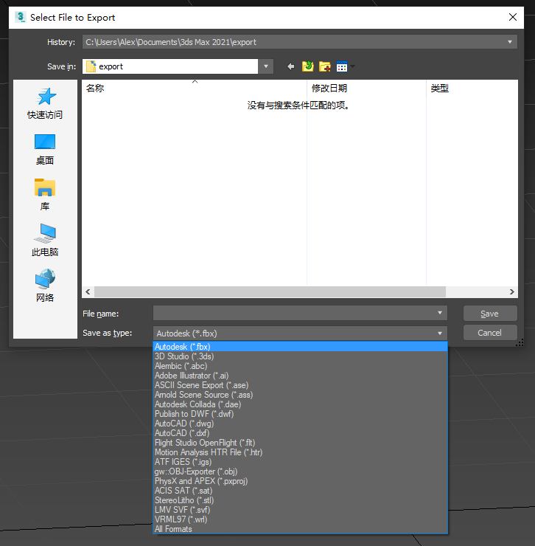

8. Store the exported file somewhere easily accessible by the Unity Team (Microsoft Teams Files) who can then import your model into the project.

# Completed Deliverables

|  |  |  |
| --- | --- | --- |
| **Trimester Deliverables** | **Status** | **Where** |
| Improved Pause Menu  - Improved visuals  - Added functionality  - Added options menu  - UI sticks with skater - Fixed controller menu button | Done | Plastic SCM |
| Folder for solutions to Unity Problems   * “Everything is Pink” * “Can’t Build Game” | Done | MS Teams files [Project 1- Sun Cycle **->** Unity Solutions to Problems] |
| 3D Model for Humanoid Robot NPC | Done | Plastic SCM |
| Player HUD   * Added a bar compass * Added a mini map | Done | Plastic SCM |
| Main Menu Scene Adjustments   * Implemented VR support | Done | Plastic SCM |
| Better organization of Microsoft Teams Files | Done | MS Teams files |
| Better organization of Unity Project   * Organized Hierarchy * Organized Project Directory | Done | Plastic SCM |

# Roadmap

|  |  |  |
| --- | --- | --- |
| **Future Deliverables** | **Status** | **Notes** |
| Quest system   * Delivery system * Integrate player HUD bar compass quest marker icons * Add quest HUD element * Integrating it with the Humanoid Robot NPC | Incomplete | Previous quest system package that exists is giving errors/doesn’t work. Should build a new one and might be better to delete the one currently in the repository. |
| Physics System   * Increasing difficulty with environment | Incomplete | This could be based on incline of the land or wind. |
| Player Ghost System   * Time Trial for the quest system | Incomplete | Similar to how it works in Track Mania the game. |
| A larger world   * Possibly a procedurally generated one. | Incomplete |  |
| Implementing the three factions documented and designed in 2022 T2.   * Terraforming land into 3 areas: Desert, Mountain, River. * Add assets from 3 factions: Mutated Humans, Dwarfs, Elves | Incomplete | Can find the documents for these in [Project 1 – Sun Cycle **->** Archived Files from Private Channels Copied 13-12-2022 **->** VR Dev – Team Project 01 – Asset creation **->** Factions and Environments] |
| Create a UML Diagram for the Project. | Incomplete | Help get a better understanding of how everything works and how things are related. |
| Visualize Speed   * Wind graphics based on player speed. | Incomplete | To give the player a better sense of speed. |

# Open Issues

* Current quest package not working as expected.
* If when using Plastic SCM the resolve conflict button does not work and gives an error message. Follow this thread to see the possible solution: <https://forum.plasticscm.com/topic/20639-unityyamlmergeexe-error-in-merge-tool/>

# Lessons Learned

Plastic SCM

The team leader should add the team members to the Plastic SCM account as soon as possible to give the team more time to start making contributions and forming ideas on the current project.

Organization

It is important to keep your file structure neat and organized so that you can easily find and access things. Having good naming conventions are a good foundation for the future.

Setup/Upskilling

It is important to become involved in the project as soon as possible, engrossing yourself in the handover documents and the project itself to get a grasp of the situation the project is currently. Alongside this it is important to upskill in the necessary skills as quick as possible so that you can start contributing as soon as possible, the trimester goes quicker than you think.

Scheduling Meetings

It is important to try and schedule more than two meetings a week to get a better grasp of what everyone in the team is up to in terms of progress, problems and plans.

Problem solving skill is important

Sometimes one way doesn’t work to solve the problem, then need to watch it in a different perspective. For example, search the problem in different languages may help to find rare answer.

Always being proactive

If nobody starts the events, then you should use your initiative to start doing something that would be proactive like prompting the leader for meetings, etc. This is the most effective way to solve things in the face of silence.

# Product Development Life Cycle

The team should attempt to meet at least twice a week. This meeting is used to understand the development progress of each member and to discuss any difficulties they encounter. You can then make a rough plan of what each member is trying to accomplish/achieve in the coming days/weeks.

## New Tasks

To start the formation of new tasks the team will get together during one of the beginning meetings to do some brainstorming for task ideas. Each of the members can contribute their own thoughts and opinions on things that could be added to the project and subsequently be added as new tasks. These new tasks can also be derived from previous trimesters backlog/incomplete/roadmap tasks.

Then using Trello we will create lists so that we can categorize each of the cards that store the tasks, with categories such as "To Do", "Doing", "Done". For example:

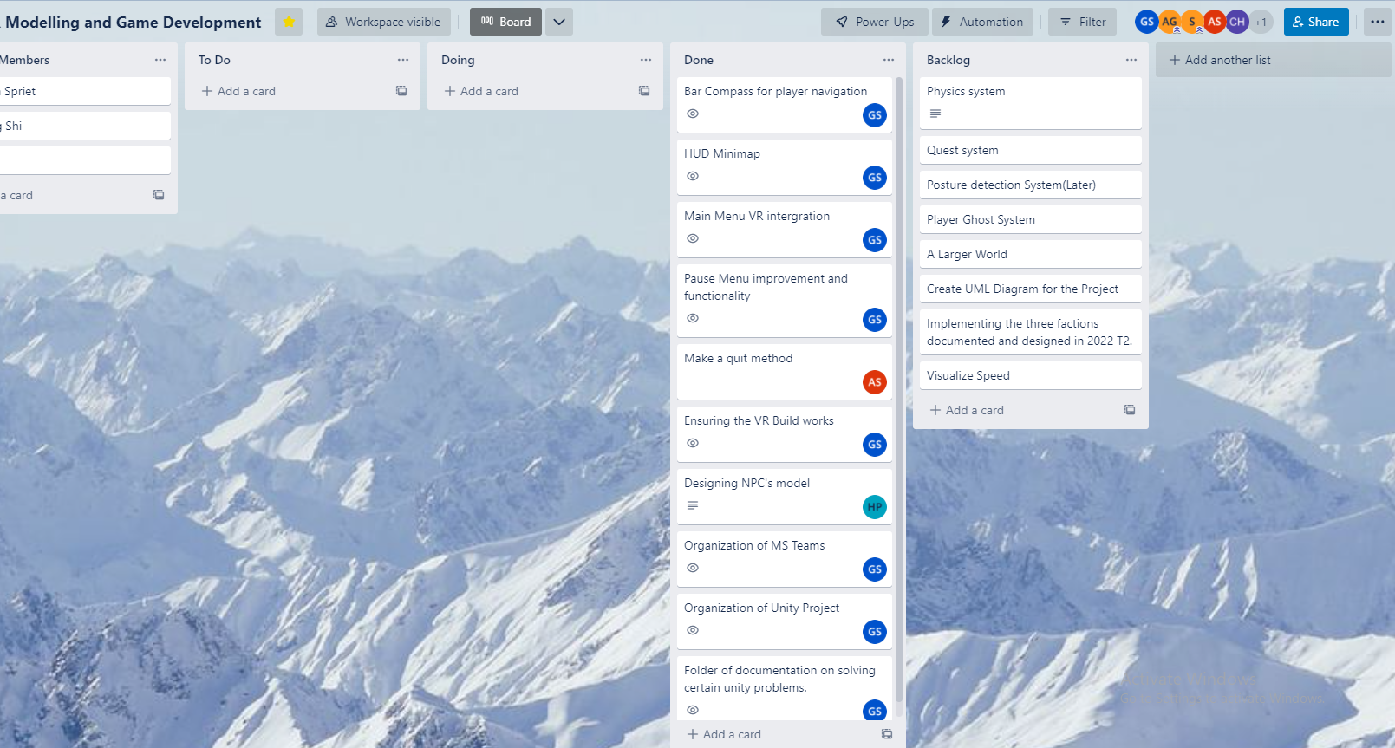

The Team leader will then sort out these ideas and then screen out highly feasible ideas with other members and put them on the "To Do" list of the Trello board as an actionable task. Then the team members will drag their name to the card of the corresponding task they would like to work on. Due to the long development cycle, after the team complete those tasks, the team will arrange some new tasks in the meeting and new tasks will be created for the next coming week of contribution work.

## Definition of Done

The basic definition of done would be a contribution with acceptable quality and is reliable with no errors. This entails things like the code must well commented, good naming conventions should be used when coding, the files need to be organized categorically and should be clearly named. The team member working on the task should also do extensive testing within their own branch of the repository to ensure there are no errors. Once these ideals are achieved the task can be seen as done.

## Task Review

Once a team member believes that their task is done, they will inform their team leader during the weekly meeting or personally chat that they have completed the task. The team leader will then examine the upcoming assets or codes alongside information that this new content has been tested successfully in the team members branched repository. If they find the new content to be of acceptable quality and reliability the team leader will then merge the contribution into the main branch of the project, meaning the task has now been reviewed. The team leader will then move the task card on Trello from the "Doing" list to "Done" list.

## Testing

Every team member will need to test the project after they completed new tasks. This process will be running in their local repository of their own Plastic SCM branch. After the contribution has been merged to the main branch a final product test should be performed by the team leader to ensure there are no error messages (red) in the debug console. If any of red messages comes out, they need to be fix immediately which means the red messages has the highest priority. While testing the task contributions the team members should use the debug console to their advantage as much as possible. Using the console will give them a way to debug their code with comments (white), give them warnings of things they might want to avoid (yellow) and give them error messages (red) which they can use to diagnose and solve a problem.

## Branching Strategy

Every team member should create their own branch and switch their workplace to their own before they start working on the project. This process allows each member to work on a specific task without disruption. It also helps their main branch not getting messy. Once the team member commits changes, the team leader will need to merge it to the main branch. After that process is over you can delete the old branch and then create a new branch for the next task the member undertakes, and this cycle continues throughout the development of the project.

For more information on how this process works refer to section 3.4.2 Using Plastic SCM.

# Product Architecture

## Tech Stack

### Software

Microsoft Teams

This software serves as a file repository as well as a way for the team to communicate with each other and the overall company.

Trello

This task assignment software allows us to give team members tasks to work on and categorize our deliverables in a structured and organised manner.

Unity (Editor Version: 2020.3.37f1)

This is the game engine being used to create the Sun Cycle project. It gives us a lot of pre-built functionality that enables us to work effectively and efficiently on the project development.

Plastic SCM

This software was built specifically for Unity as a Repository System that allows us to share the most up-to-date game versions, models, assets and code with each other.

Blender / Maya

These are 3D modelling software's that can be used to create and design the assets we will need within the project to make it come to life.

### Hardware (Not required)

Virtual Reality Headset + Controllers

To test and play the VR version of the project you will need a VR set, this could be provided by the University, or you can use your own. A headset known to work with this project is the Oculus/Meta Quest 2. If you use another headset you **might** need to reconfigure some project settings.

Exercise Bike

To play the final build of the VR game the way it was intended you will need an exercise bike. Before playing just make sure to attach the **right** controller to one of the pedals of the bike as this will allow the game to track your acceleration within the game.

# Source Code

**To access source code, refer to section 3.4 Plastic SCM**

Backup

A backup of the project can be found in the Microsoft Teams files under

[Project 1 – Sun Cycle **->** 2022 T3 **->** Project Backup]

# Login Credentials

To gain access the Unity Project and its repository so you can work on the project you will need to be added to the Plastic SCM. To add Unity users to the Plastic SCM you will need to go to the Plastic SCM website and login using the email [redbackoperations.au@gmail.com](mailto:redbackoperations.au@gmail.com) and the password that can be found in the Team Leaders Channel “Passwords and Usernames” Excel Spreadsheet.

# Other Relevant Information

Unity Packages

Check to make sure the Unity packages the project is using are up to date and there are no conflicts with other packages that are already used in the current project.

Unity Version

In the future you could possibly investigate upgrading the unity project to a newer version. Look into possible problems this could cause beforehand of cause and make a backup just in case.

Plastic SCM

The free version of the Plastic SCM subscription only allows for 3 users, so if there are more than that then don’t forget to check and to pay the subscription or else you might be locked out of the repository.

Handover Documents

If you want more information on the project and the tasks completed before 2022 T3 have a look at the older hand over documents which can be found in two folders called “2022 T1” and “2022 T2” and then in the folder “Handover Document”

# Appendices

## Showcase Video

Showcase Video Link: <https://video.deakin.edu.au/media/t/1_beghe4pg>

## Documentation Deliverables

Organization of Microsoft Teams files

***Before***

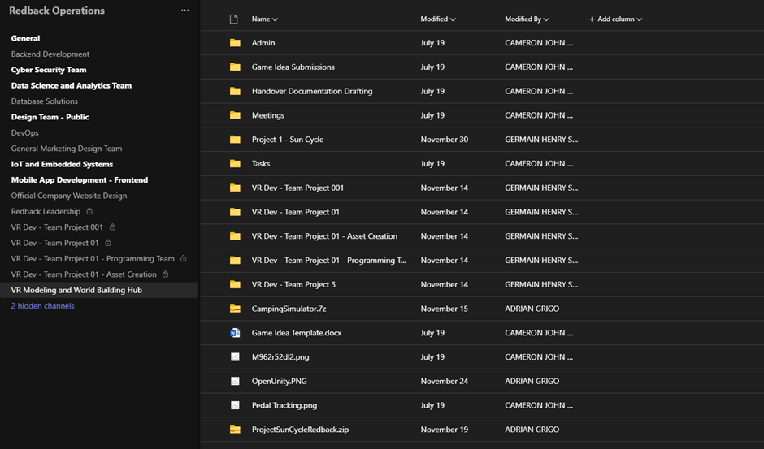

***After***

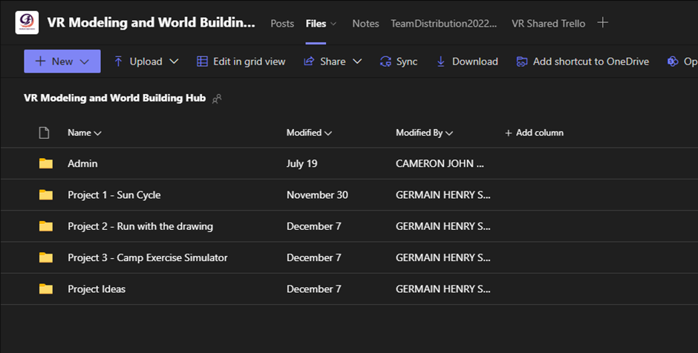

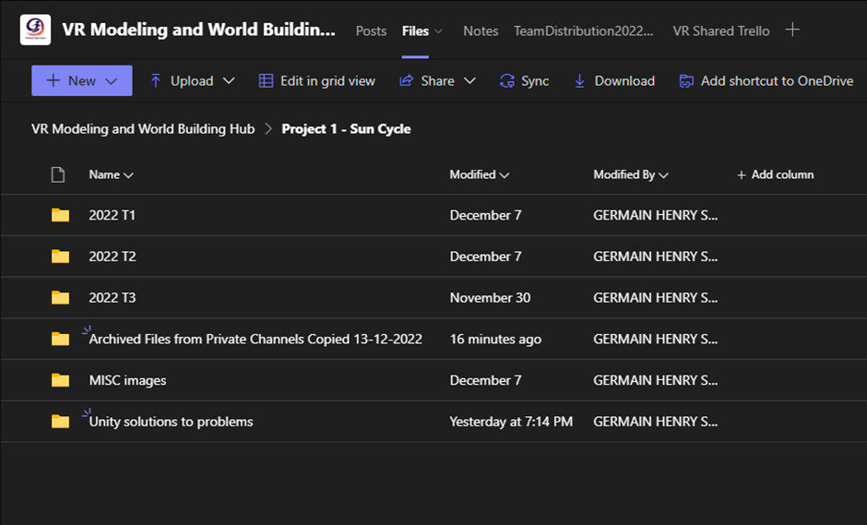

Unity Solutions to problems documents

**Folder – can be found here: [Project 1- Sun Cycle -> Unity Solutions to Problems]**

* “Everything is Pink” (Word Doc)
* “Can’t Build Game” (Word Doc)

## Unity Deliverables

Organization of Unity project

1. **Hierarchy**

***Before***

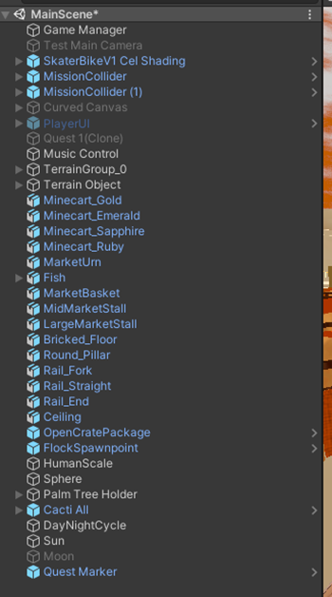

***After***

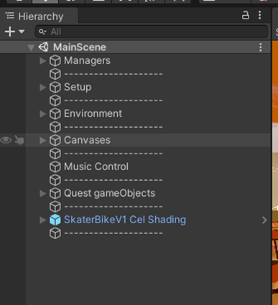

1. **Directory (main)**

***Before***

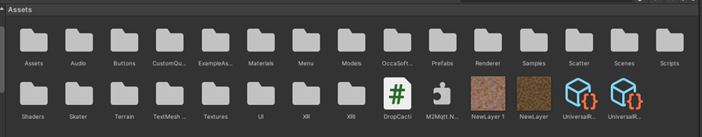

***After***

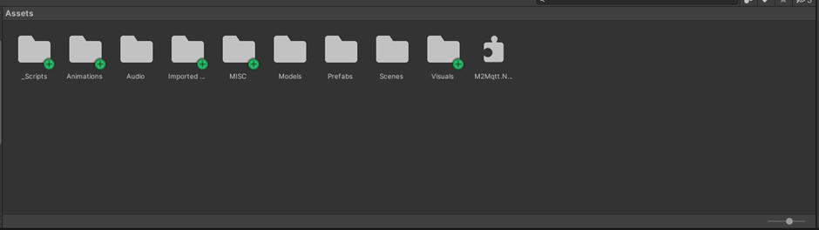

1. **Directory (scripts)**

***Before***

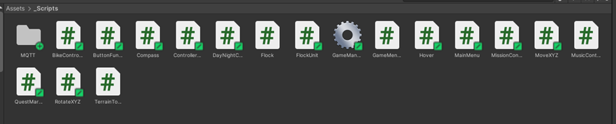

***After***

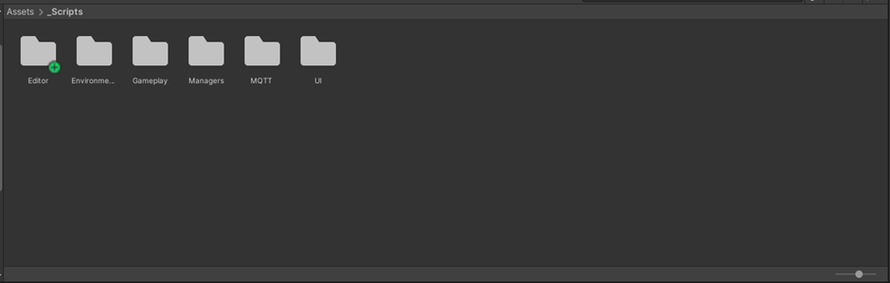

Player HUD Bar Compass

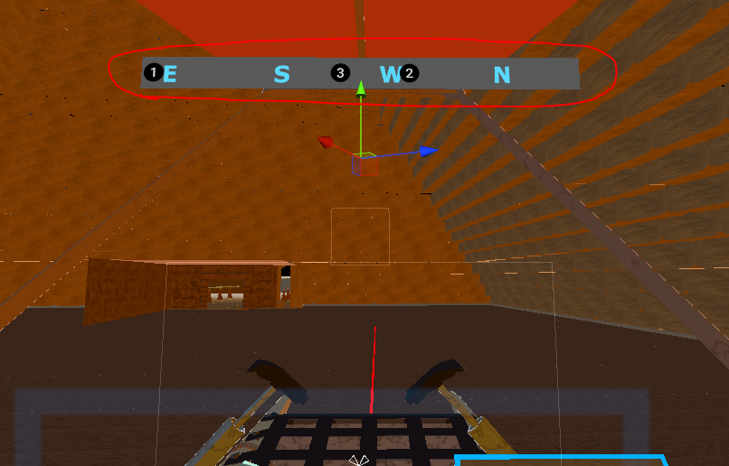

Player HUD Mini Map

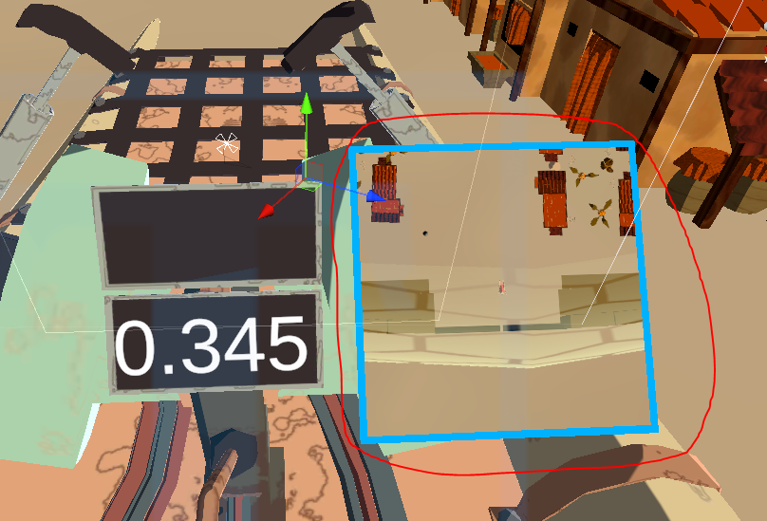

Improved pause menu visuals and functionality

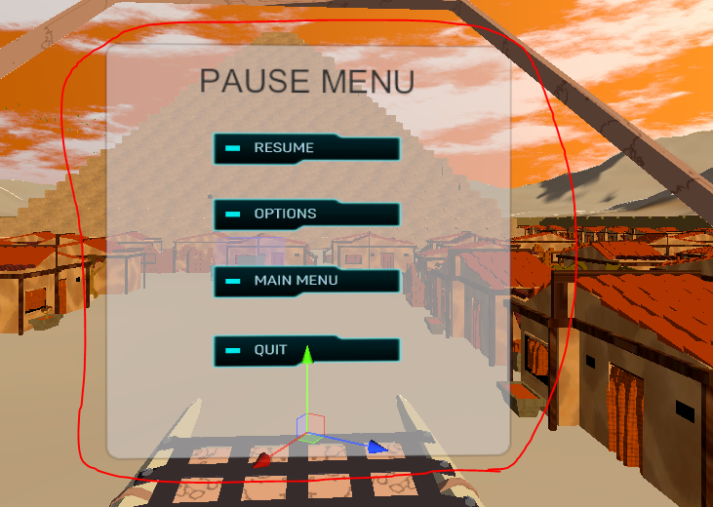

Added an options menu with volume slider

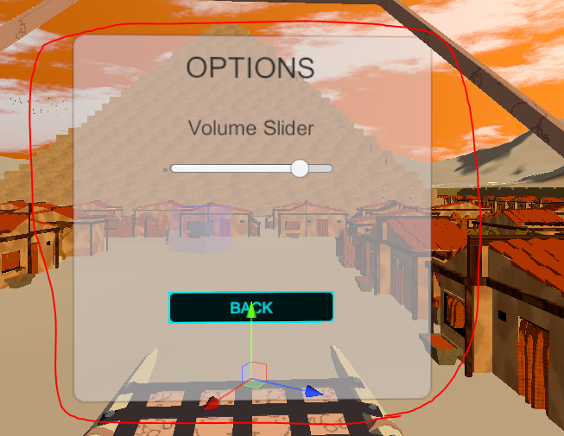

VR Intergration for Main Menu Scene

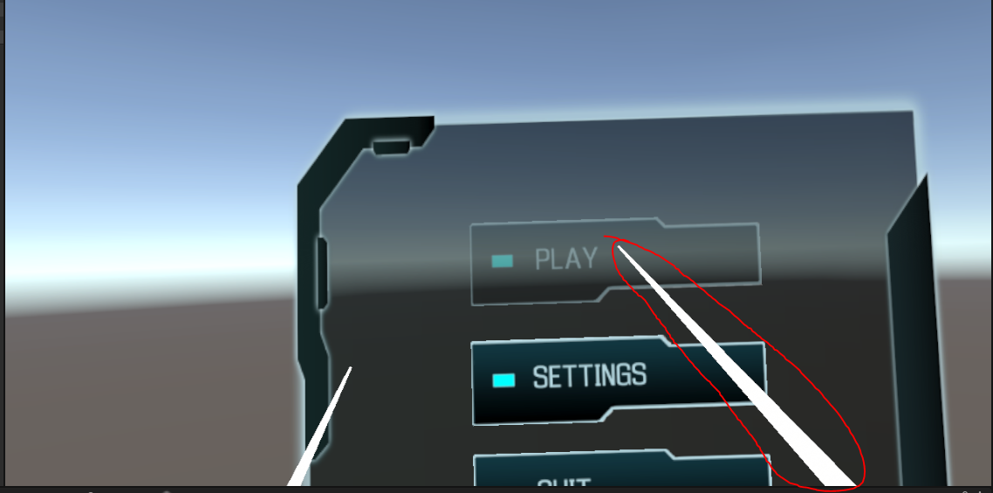

Other MISC Unity Deliverables

* Button used to call Menu by using Oculus Quest 2(Input Setting)

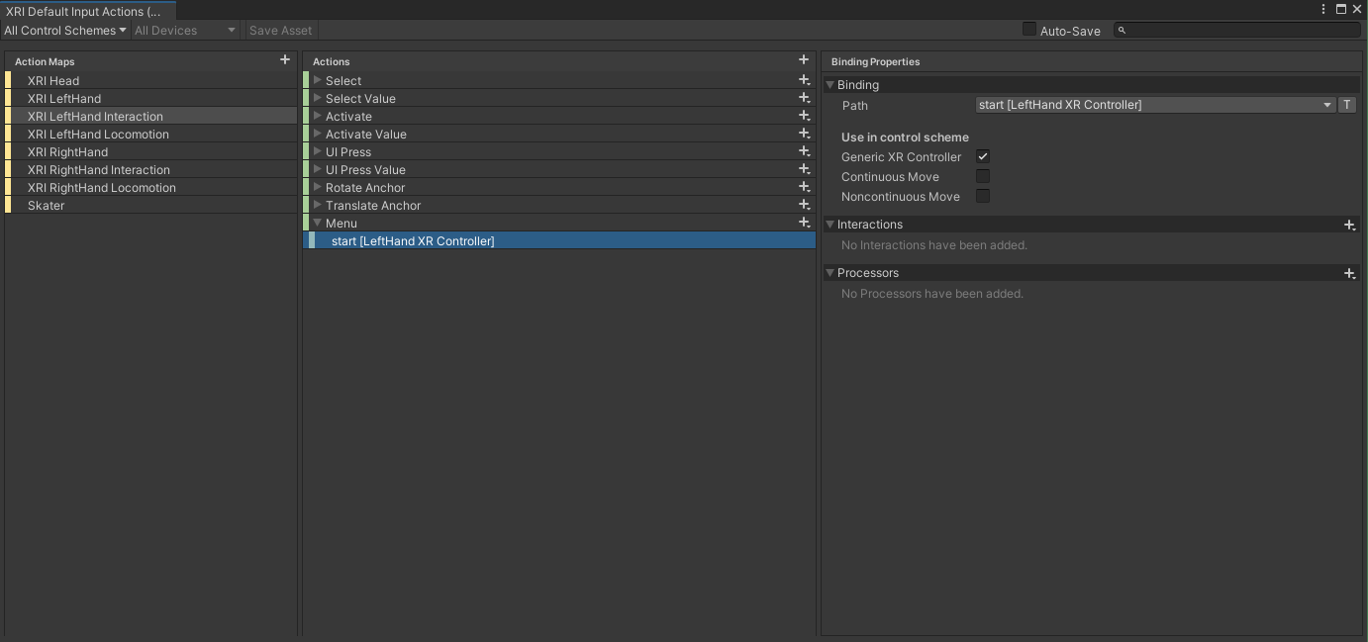

* Quit game method

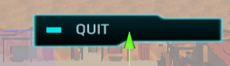

* VR Canavas interaction set up

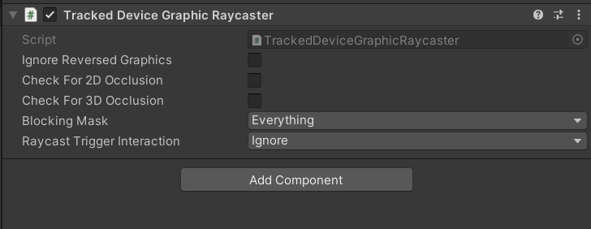

* Examined the current quest system

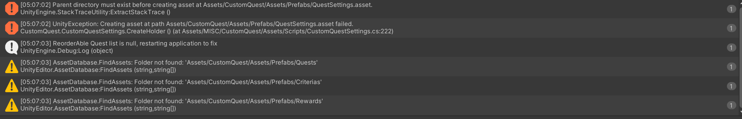

* VR Environment configuration issue fix

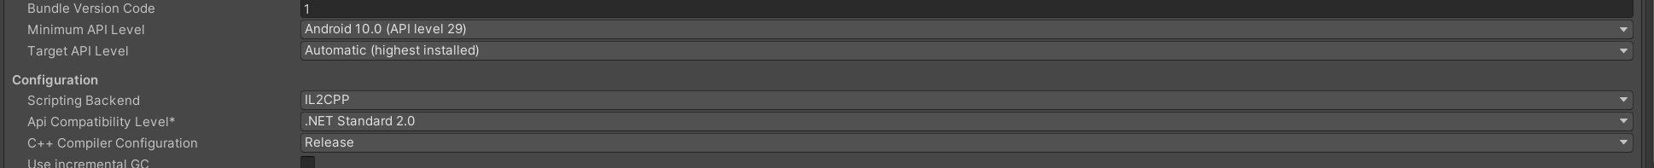

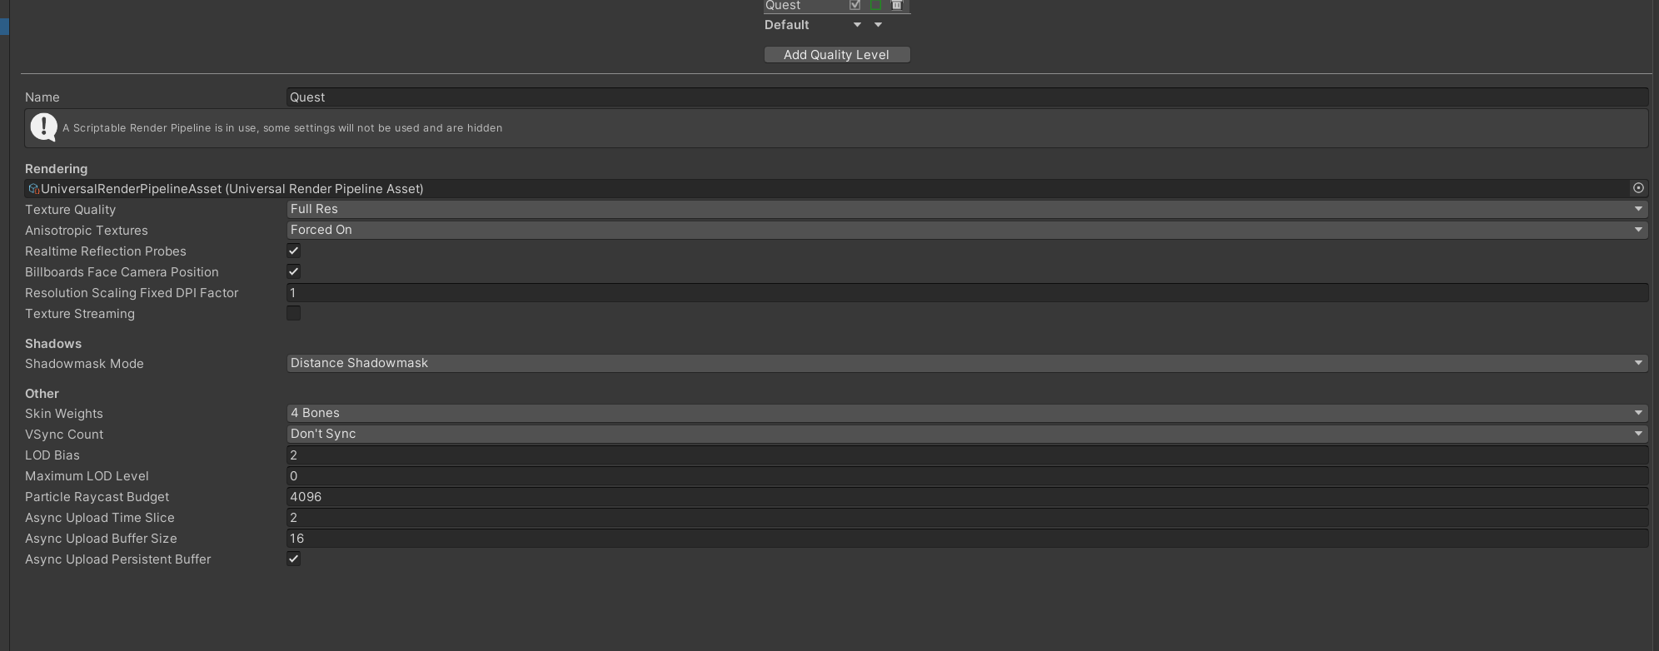

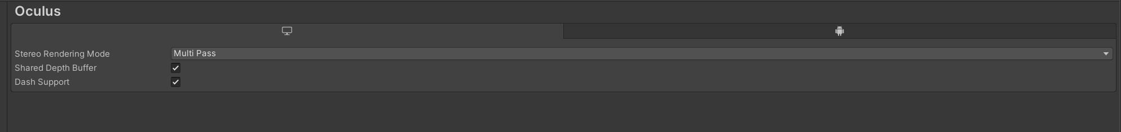

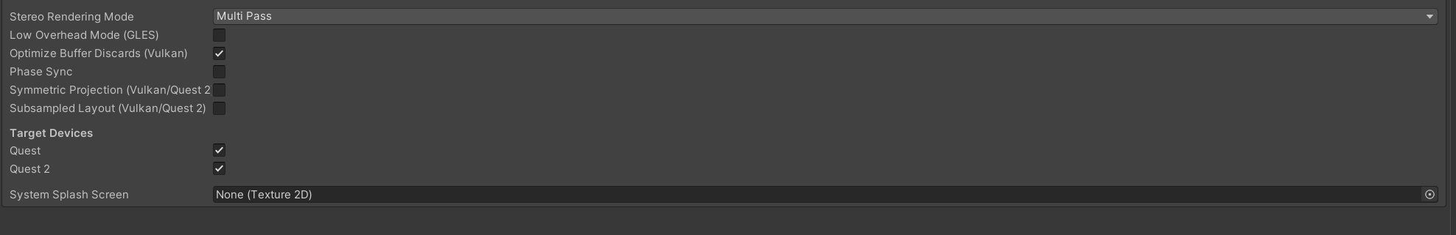

* Fixed an issue that was causing the skybox to render weirdly

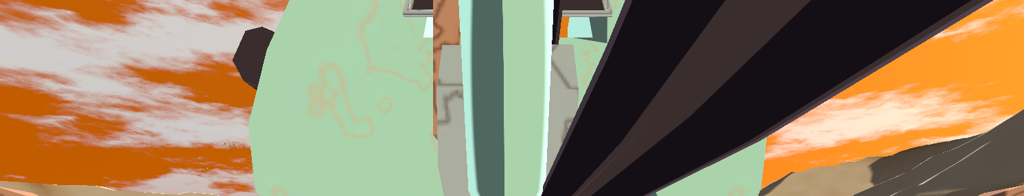

## 3D Asset Deliverables

3D Model (Humanoid Robot NPC):

1. Start it with a prototype sketch / reference art.

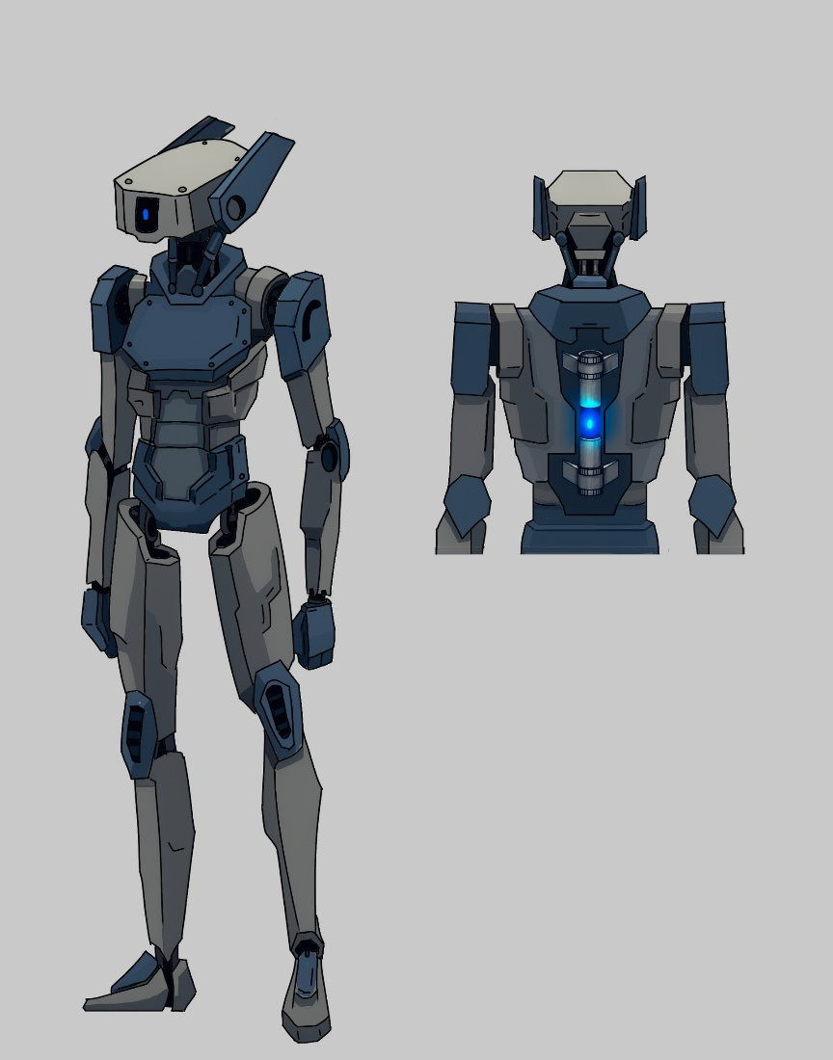

2. Low poly models, just make sure it has the correct size and basic parts needed for the model.

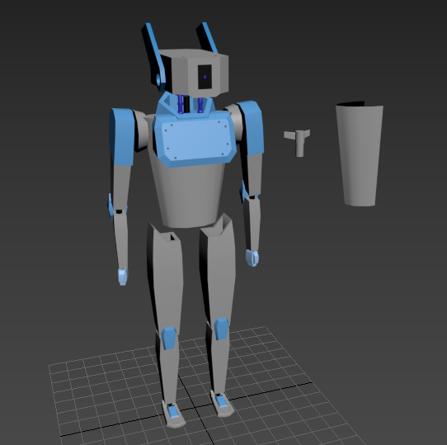

3. High poly models, the detail processing and turbo smoothing.

Add more details, such as the model's Armor, hands, feet and joint parts of the bones.

Then add normal to the model and perform turbo smoothing.

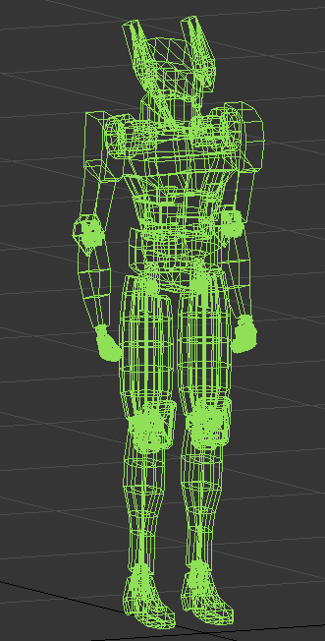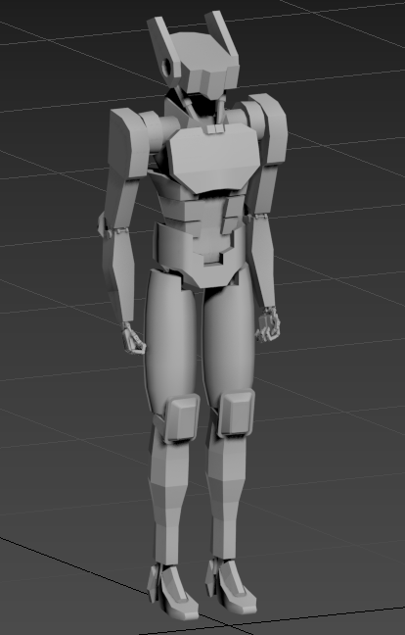

4. UV mapping, spread the 3D model into a 2D plane graphic for disassembly and arrangement.

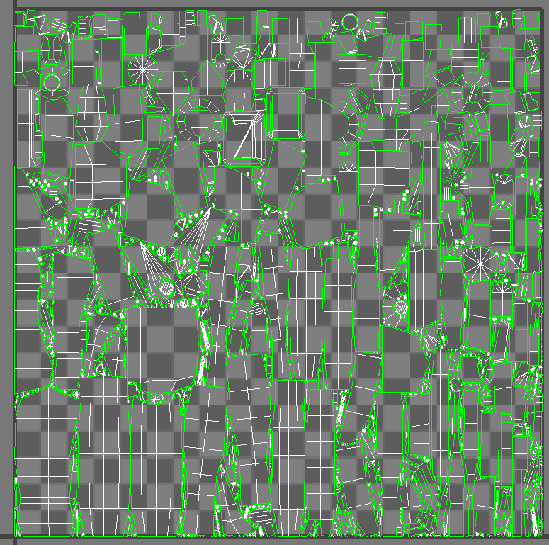

5. UV painting and material application, draw various parts of the model through the drawing tool to generate material requirements.

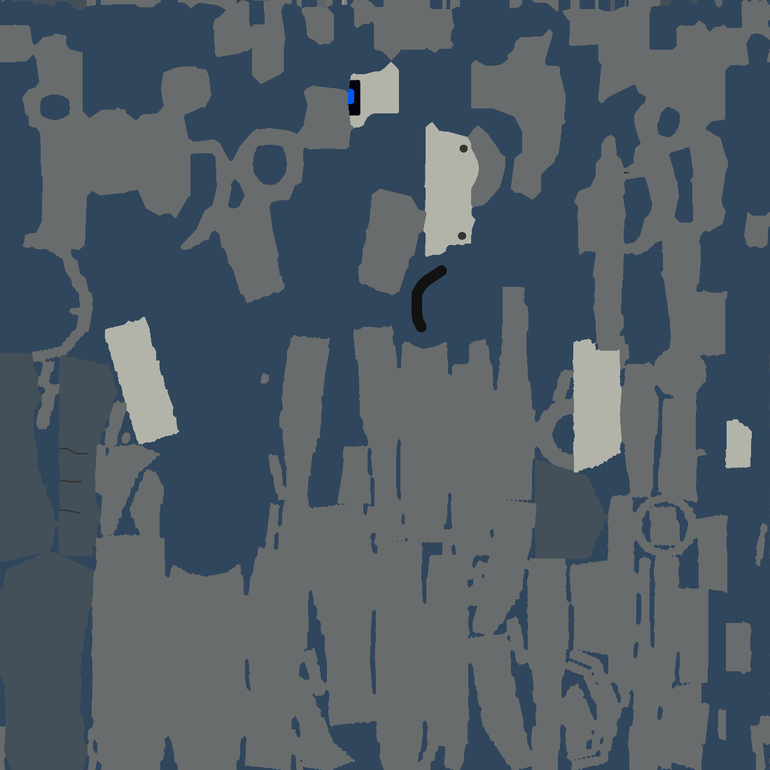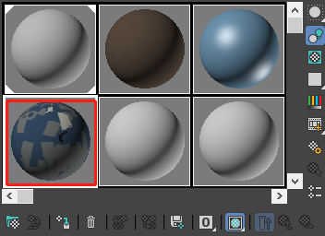

6. Apply the material, and export the model to FBX format, import the model into the unity project.

